# Executive Summary

This report compares five competing models in terms of their forecasting performance for five individual assets in America: COKE, PTR, MMM, JNJ and MSFT. For return forecasts, the competing models are: AR-GARCH, AR-GJR-GARCH, Historical Simulation of last 25 and 5 days (HS-25 and HS-5). That is two parametric and two non-parametric models in total. As for volatility forecasts, the fifth model, IGARCH, is introduced since it generally outperforms other GARCH type models. We will compare the forecast results of each assets generated by these models. These forecasts form the basis of portfolio weights allocation.

# Exploratory Data Analysis

As suggested by Tsay (2010), the log transformations are taken for all 5 return series, since log returns have the statistically favourable property of additive. As can be seen from **Figure 1**, all 5 assets have a stationary daily mean return of approximately zero. However, the volatility is non-stationary, which was especially dynamic during and shortly after Global Financial Crisis (GFC) and stabilised from about 2010 after GFC, and also before the GFC when the market was booming.

Overall, as can be observed from **Table 1**, PetroChina (PTR) showed the highest volatility, with standard deviation of 2.28, which is almost twice of the Johnson & Johnson (JNJ), Coca-Cola (KO), and 3M (MMM)’s standard deviations. PTR’s returns also showed a wide range with maximum return of 14.41% and minimum of -14.90%. Additionally, as can be seen from **Figure 1** (specified using red circle), PTR among others was highly volatile both at the beginning and the end of GFC period. The second most volatile stock was Microsoft (MSFT) with standard deviation of 1.65. It has about the same extremes as PTR (maximum 17.06, minimum -12.46). Notably, MSFT had several dramatic soar and drop from time to time, which is specified using black rectangle in **Figure 1**.

In quite a distinct comparison, JNJ, KO and MMM showed low volatilities overall, as their log returns are quite close to zero from **Figure 1**. The reason behind this should be the fact that they are belonging to healthcare, consumption, and industrial goods industries respectively. Thus, they are more closely connected to human necessities compared to the stocks from the fancy technology industry .

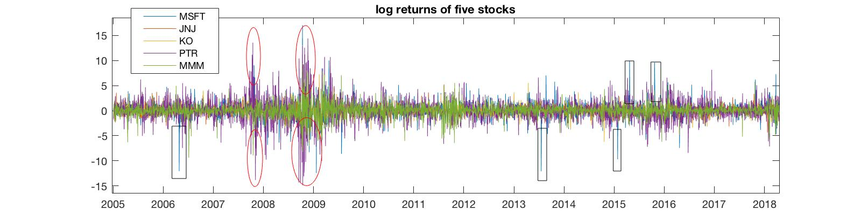

**Figure 1:** Log returns for MSFT, JNJ, KO, PTR, MMM

|  |  |  |  |  |  |  |  |
| --- | --- | --- | --- | --- | --- | --- | --- |
|  | **Mean** | **Median** | **Std** | **Min** | **Max** | **Skewness** | **Kurtosis** |
| **MSFT** | 0.0373 | 0.0137 | 1.6521 | -12.4578 | 17.0626 | 0.0895 | 13.7958 |
| **JNJ** | 0.0208 | 0.0145 | 0.9980 | -7.9749 | 11.5373 | 0.3413 | 14.1704 |
| **KO** | 0.0218 | 0.0442 | 1.0885 | -9.0681 | 12.9971 | 0.4119 | 16.2519 |
| **PTR** | 0.0097 | -0.0089 | 2.2815 | -14.9027 | 14.4147 | -0.0509 | 8.9502 |
| **MMM** | 0.0256 | 0.0568 | 1.3449 | -9.3837 | 9.4204 | -0.4136 | 9.8340 |

**Table 1**: Summary statistics for MSFT, JNJ, KO, PTR, MMM

In terms of means and medians, as can be seen from **Table 1**, all assets had positive average and median daily returns around zero during the in sample period except for the PTR’s median of -0.01%.

A discovery of the five stocks’ skewness and kurtosis can be conducted by combining the summary statistics (**Table 1**) with their histograms (**Figure 2**). Due to the relatively more existence of extreme outliers in either direction as can be exploited from **Figure 2**, MSFT, JNJ and KO had positive skewness, while PTR and MMM were negatively-skewed. The kurtosis of all 5 stocks were way above the normal distribution’s kurtosis of 3. It indicated the negligibility of extreme outliers and heavy tails in the distributions. As a result, t-distribution instead of normal distribution is assumed in the following analyses.

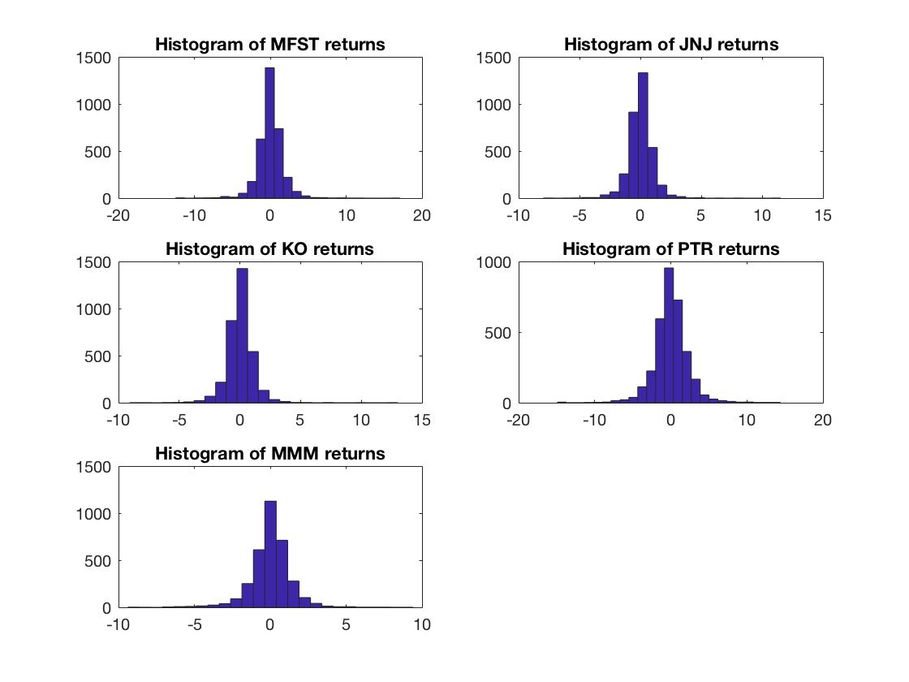

**Figure 2**: Histograms for MSFT, JNJ, KO, PTR, MMM returns

# Factor Modelling

## Descriptions of Factor Model and Factor Modelling

In asset pricing theories, factor model is widely used to analysis common factors explaining asset returns. The most famous factor models are CAPM which is a single factor model, and Fama-French three-factor model. Factor model can be written in vector-matrix form as follow:

Factor model assumes error terms are independent to each other and to each factor. By taking the historical data of five stocks chosen, we conducted one factor and two factors analysis.

Factor modelling is employed as a way to reduce the dimensionality, as the unknown factors can be generated to explain asset returns. As an advantage over its special-case Principal Component Analysis, factor modelling can explain both linear and non-linear relationships. Although it has the disadvantage of being difficult to be interpreted as the factors are unknown, and the factor loadings are not fixed that lead to non-unique results, this difficulty can be overcome by employing factor rotations as will be discussed further.

## One Factor Analysis

By implementing MATLAB function—“factoran”, the result of one-factor analysis is obtained as in **Table 2**:

|  |  |  |  |  |
| --- | --- | --- | --- | --- |
| Stocks | Factor Loading | SER 2 | SER | Adjusted R 2 |
| MSFT | 1.1262 | 1.4609 | 1.2087 | 0.4647 |
| JNJ | 0.7105 | 0.4911 | 0.7008 | 0.5069 |
| KO | 0.7422 | 0.6340 | 0.7962 | 0.4649 |
| PTR | 1.3925 | 3.2664 | 1.8073 | 0.3725 |
| MMM | 1.0227 | 0.7629 | 0.8734 | 0.5782 |
| Percentage (%) Variance | 45.52% |  |  |  |

**Table 2**: One-Factor Model Analysis

Table 2 indicates that factor loadings for five stocks are all around 1 with difference no more than 0.4. PTR has the highest factor loading with 1.3925 while the JNJ has the lowest (0.7105). It makes sense to explain the single factor as market factor because it influences all five stocks positively to similar extent. Thus, factor loadings can be considered as sensitivity of stocks toward market variation. Stock from consumption industry like KO (Coca Cola) and from healthcare industry like JNJ are less sensitive to this factor with factor loadings around 0.7. MSFT from technology as well as PTR classified as “other” industry has comparably higher factor loadings of 1.1262 and 1.3925 respectively indicating that they are more sensitive to this factor than the other assets. and are specific error variance not explained by the factor. The factor does not explain individual stock returns ideally since SERs are between 0.7088% to 1.8073% while the standard deviation of stock returns are in range of 0.9980% to 2.2815%. Also, daily of this scale is considered to be significant. Adjusted leads to same conclusion, since only around 50% of variances for individual stocks are explained by one-factor model. The factor explains stock PTR poorly for Adjusted being only 0.3725 and being the highest. Single factor only captures 45.52% of overall variance.

图片包含 屏幕截图

已生成极高可信度的说明

**Figure 3**: Variations explained by the 1st factor

As shown in **Figure 3**, the single factor captures rough overall fluctuations but does not capture some extreme changes of individual stock. For example, the MSFT has extreme returns which is not captured by factor at 400th, 2100th, 2500th, 2700th day.

In addition, by doing a hypothesis test, the null hypothesis of: the number of factors is equal to 1 is strongly rejected for p-value being . Thus, the 2-factor model is necessary to be further employed.

## Two Factor Analysis

|  |  |  |  |  |  |
| --- | --- | --- | --- | --- | --- |
| Stocks | 1st Loadings | 2nd Loadings | SER 2 | SER | Adjusted R 2 |
| MSFT | 1.0902 | 0.4109 | 1.3719 | 1.1713 | 0.4973 |
| JNJ | 0.3425 | 0.9347 | 0.0050 | 0.0706 | 0.9950 |
| KO | 0.6048 | 0.3926 | 0.6650 | 0.8155 | 0.4388 |
| PTR | 1.4292 | 0.4139 | 2.9915 | 1.7296 | 0.4253 |
| MMM | 0.8830 | 0.4750 | 0.8035 | 0.8964 | 0.5558 |
| Percentage (%) Variance | 51.05% |  |  |  |  |

**Table 3**: Two-Factor Model Analysis

In factor analysis, adding the next factor would influence loadings of the first factor. As shown in Table 2, the first factor again has a positive effect on individual stock returns. PTR still has the highest 1st loadings, 1.4292 while JNJ has the lowest, 0.3425. It is hard to identify and interpret the first factor because the differences between the 1st loadings of each stock, if ranked from the lowest to highest, are all approximately 0.2 to 0.3. A possible explanation is that the first factor distinguishes MSFT and PTR which have loadings larger than one from the other three stocks: JNJ, KO and MMM. Yet as for the second factor, JNJ shows the highest 2nd loadings when the other four stocks all have values around 0.4. Thus, this is more like a factor driving return on healthcare stock or a healthcare-dominated factor.

In terms of SER2 and SER, PTR and JNJ each maintains the highest and lowest values respectively. It is worth noting that the SER of JNJ is close to zero indicating that the second factor has a very comprehensive explanation of JNJ’s returns. The adjusted R2 also shows that the second factor has a strong explanatory power for JNJ.

The 2-factor model captures 51.05% of variation across 5 stock return series and is slightly improved comparing with 1-factor model.

图片包含 屏幕截图

已生成极高可信度的说明

**Figure 4**: Variations explained by the 1st and 2nd factor

As illustrated by **Figure 4**, the first factor has relatively big variation around 1000th day and 1700th day, which is close to MMM stock return variation shown in the first panel. This observation explains reason why MMM has 1st factor loading being close to 1. The second factor has less variation because it captures nearly 100% variation in JNJ returns which have almost no extreme value shown by the first panel in **Figure 4**.

The correlation between factor 1 and 2 is calculated and it is equal to -0.1397 indicating that these two factors are negatively correlated and are not independent to each other. Although the relationship between two factors is not strong, the result violates assumption of factor independence to some extent.

As can be seen in Table 3, the variances explained are only 51.05%, thus we tried to employ the third factor to give more explanations. However, MATLAB shows that “The number of factors requested, M, is too large for the number of the observed variables.” Thus, unfortunately, we cannot conduct three factor model analysis.

## Comparison between one-factor and two-factor model

|  |  |  |  |  |  |
| --- | --- | --- | --- | --- | --- |
|  | MSFT | JNJ | KO | PTR | MMM |
| std of stock returns | 1.6521 | 0.9980 | 1.0885 | 2.2815 | 1.3449 |
| SER(m=1) | 1.2087 | 0.7008 | 0.7962 | 1.8073 | 0.8734 |
| SER(m=2) | 1.1713 | 0.0706 | 0.8155 | 1.7296 | 0.8964 |
| R2(m=1) | 0.4647 | 0.5069 | 0.4649 | 0.3725 | 0.5783 |
| R2(m=2) | 0.4973 | 0.9950 | 0.4388 | 0.4253 | 0.5558 |

**Table 4**: Comparison between 1-factor and 2-factor modelling

As shown in **Table 4**, one factor model has specific error standard deviation being only about 0.4 less than original standard deviation of individual stocks. In addition R2s of one-factor model are around 0.5 or less. These two criteria indicate that one factor model has poor explanation of stock returns. Comparing with one-factor model, two-factor model has lower SER and higher R2 for MSFT, PTR and especially JNJ while the opposite situation happens for KO and MMM. Although it is hard to see that model 2 is improved compared to model 1 based on **Table 4**, the overall R2 for two-factor model is 51.05% which is 5.53% higher than one-factor model.

As a result, two-factor model is preferred because it can almost perfectly explain JNJ returns and it is the best strategy we can formulate given the 3rd factor cannot be generated using MATLAB.

## Factor Rotations

The benefit of factor rotation is the better interpretability. As we can see from **Figure 5** and **Table 5**, the JNJ is more clearly separated out according to the second factor, with all other stocks’ loading close to zero. This thus improve the interpretability of the second factor to be more distinguishing JNJ from other assets.

Another benefit from the rotation is that compared with the original 2-factor modelling, this rotated one has a better interpretable 1st factor. As the loadings are more equally weighted, the 1st factor acts more as the role of market factor.

|  |  |  |
| --- | --- | --- |
| **Loadings** | **Factor 1** | **Factor 2** |
| **MSFT** | 1.1626 | -0.0756 |
| **JNJ** | 0.6977 | 0.7101 |
| **KO** | 0.7129 | 0.1080 |
| **PTR** | 1.4726 | -0.2127 |
| **MMM** | 1.0003 | 0.0683 |

**Table 5**: Factor Loading after Rotation

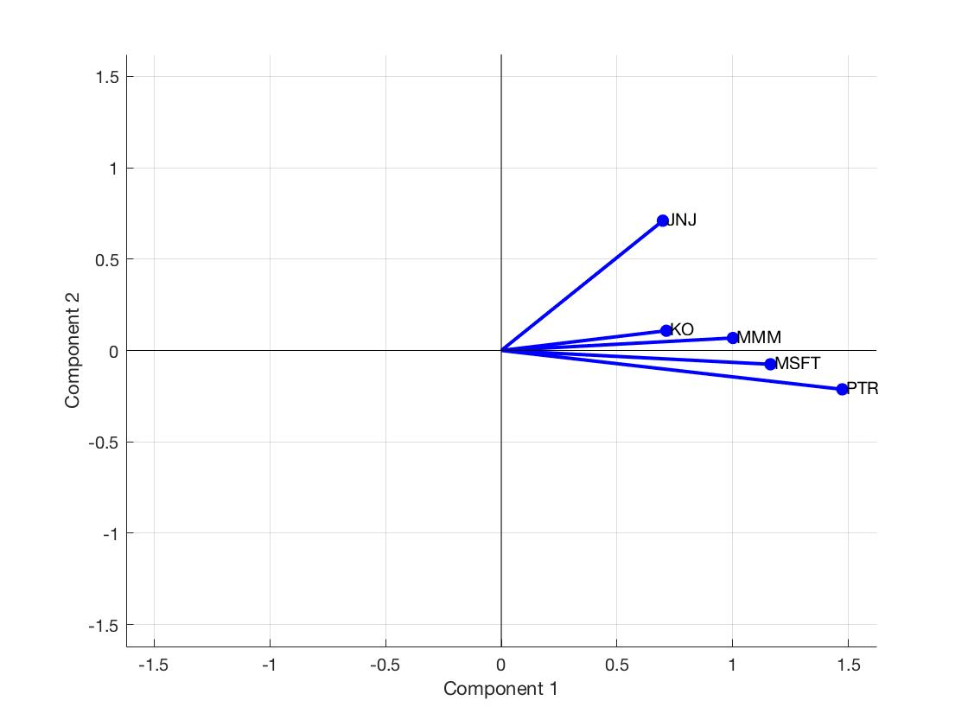

**Figure 5**: Factor Loading after Rotation

# Methodologies

## Motivations for Model Selections

Financial time series data are normally expected to have the properties of autocorrelations and heteroskedasticity. For our five chosen assets, the ACF plots of the log-returns and squared log-returns suggest that there are significant autocorrelations and ARCH effects among all the assets. Therefore, we introduce mean and volatility equations to capture them.

For the mean equations, the AR type models are used to capture the mean processes in the assets by including the lagged log-return terms. As for the volatility equations, the GARCH, GJR-GARCH and IGARCH are employed in order to capture the volatility processes in the assets. The GARCH model is a generalized GARCH type model in modelling the volatility of the time series data by including lagged innovation terms and lagged variance terms. The GJR-GARCH models are employed here to capture the leverage or asymmetric effects in the assets since normally volatility seems to be negatively correlated with prices. The IGARCH models are simplified version of GARCH models since the parameters in the models add up to 1. Given that IGARCH generally performs well in forecasting the volatility of assets, we include it in our models only for volatility forecasts.

Since financial time series data are usually expected to have fat tails, we assume the errors in the GARCH and GJR-GARCH models to have t-distribution so as to better model the volatility processes in the assets.

## Models Selected for Forecasting

We only include one autoregressive term in each of the models and there are several reasons. First, in most of the models, the AR terms are insignificant. Besides, the results of AIC and SIC in most time suggest the order of AR(1) and include more lagged terms in the models might introduce the problem of overfitting. Consider that we are more interested in forecasting the volatility of the assets, we want to simply the mean equations. For the purpose of the forecasting returns, we decide to use AR(1) as the mean equation for the models.

The order selection for the volatility equation is also based on the results of AIC and SIC, which indicate the choice of GARCH(1,1) for all the models. Therefore, for each of the assets, we use AR(1)-GARCH(1,1)-t and AR(1)-GJR-GARCH(1,1)-t. LB tests on the standardised residuals and squared standardised residuals ae conducted to test if the mean and volatility equations are well specified and JB test is also conducted to test the t-distribution assumption of the errors. The modelling results of the assets will also be discussed in the following and only COKE will be discussed in detail for demonstration.

* + 1. AR(1)-GARCH-t Model

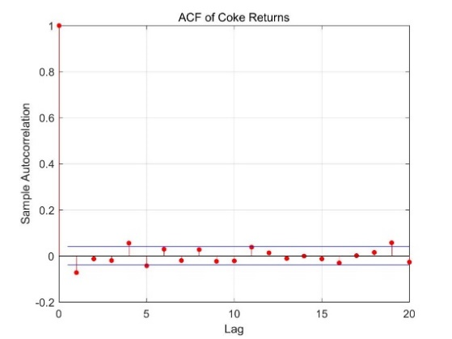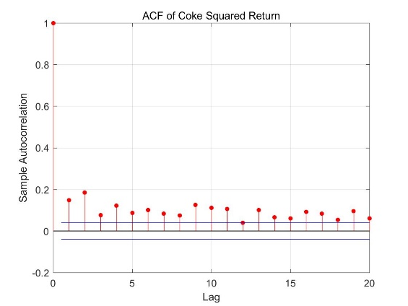

**Figure 6**

The ACF plots in **Figure 6** for the return series and the squared return series suggest that there are significant autocorrelations and significant ARCH effects in the log-returns.

Since we already decide to choose AR(1) as the mean equation, SIC and AIC are used to find the optimal order for GARCH in the range of 1 to 5 lagged squared shocks and 1 to 5 lagged conditional variances. As is seen in the result, both AIC and SIC prefer the choice of GARCH(1,1).

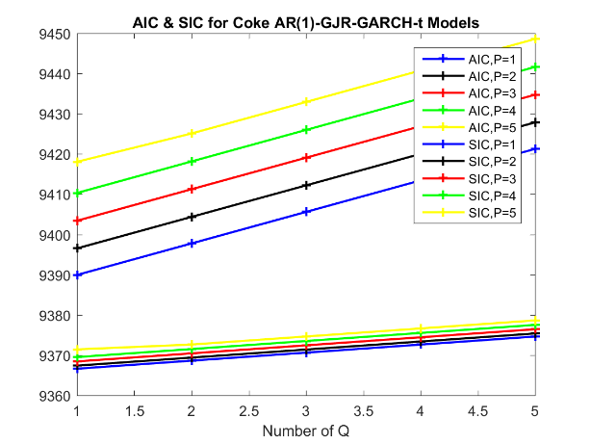

**Figure 7**

Therefore, we fit a AR(1)-GARCH(1,1)-t for COKE: (values in the brackets are the standard error)

,

(0.0259) (0.0205)

(0.0401) (0.0257) (0.0269)

All the parameters are significantly different from zero except the constant term in the mean equation. The absolute value of the AR parameter is less than 1 and the volatility persistence is estimated 0.9631, which is also less than 1, indicating the requirement of stationarity is met. The high volatility persistence indicates strong persistence in volatility and slow mean reversion. Low degrees of freedom of 4.35 implies that the tail behavior in the innovations is much heavier than that of Gaussian.

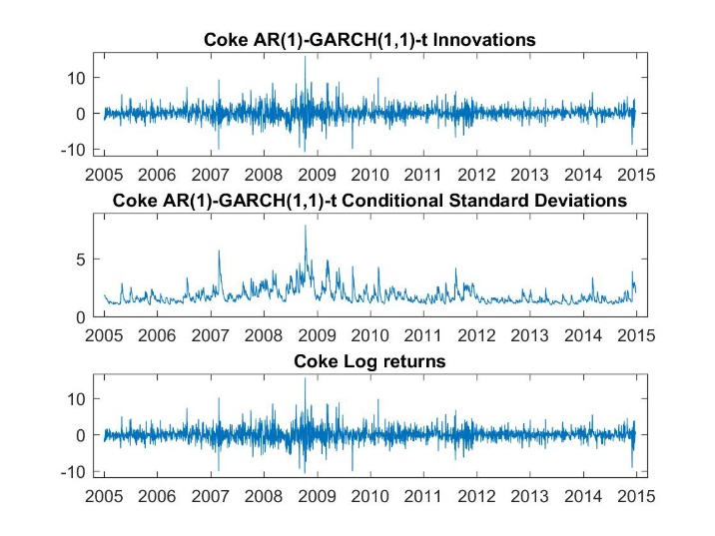

**Figure 8**

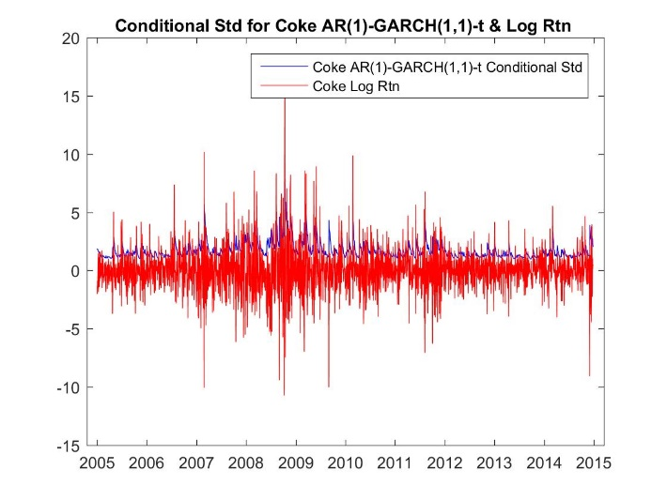

**Figure 9**

**Figure 8** shows the innovations, conditional standard deviation and the log-returns. **Figure 9**

plots the conditional standard deviation against the log-returns. As can be seen from the graphs, the conditional standard deviation seems nice and smooth and sits nicely “on the shoulder” of the returns.

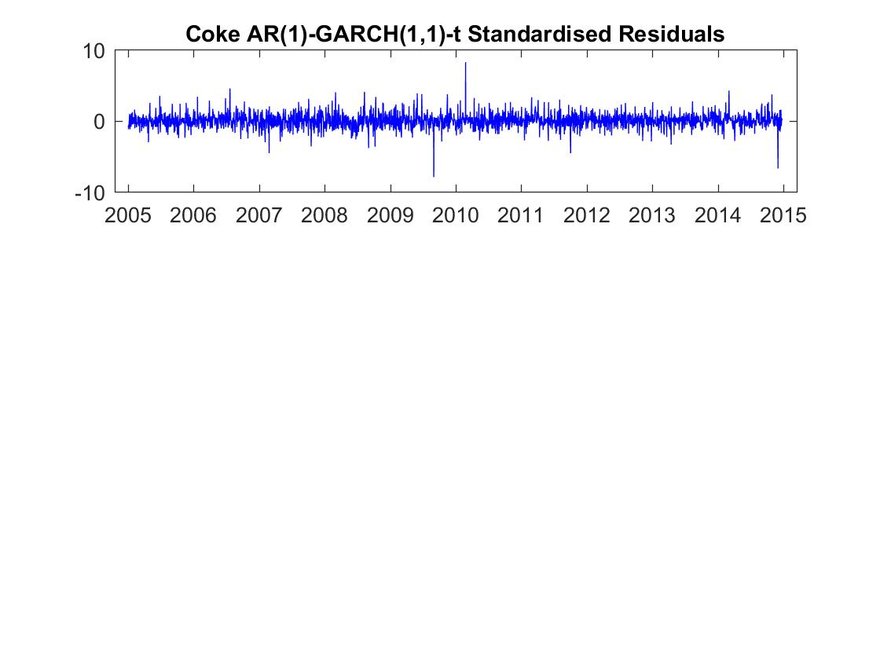

**Figure 10**

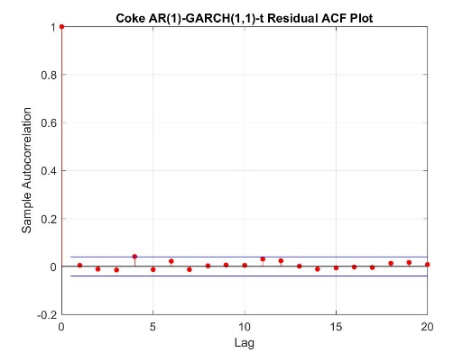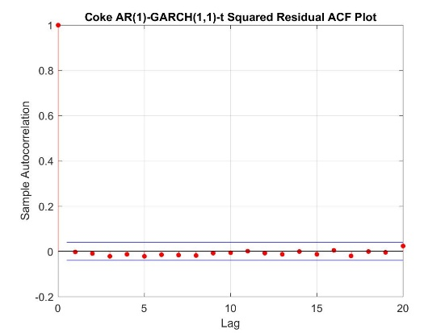

**Figure 11**

We proceed to assess the standardised residuals , which is plotted below together with its ACF and the ACF of the squared residuals. The standardised residuals seem nice and smooth, although with some outliers and appear to show little remaining autocorrelations or obvious heteroskedasticity, which is also true in the squared standardised residuals as all the points are within the confidence interval. These all suggest that both the mean and volatility equations are well specified, which can be verified by the LB test:

|  |  |  |
| --- | --- | --- |
| p-value | m=9, d.f=5 | m=14, d.f=10 |
| Standardized Residuals | 0.1120 | 0.2442 |
| Squared Standardized Residuals | 0.2851 | 0.7831 |

**Table 6**: LB test results on the standardized and squared standardized residuals

All the p-values in the test are greater than 0.05, we therefore do not reject the null hypothesis of no autocorrelations in the standardised and squared standardised residuals, which confirms the conclusion that the mean and volatility equations are well specified.

The histogram of the transformed standardised residuals appears to be more fat-tailed than Gaussian distribution with some outliers. But the qq-plot of both tails do not departure from normality.

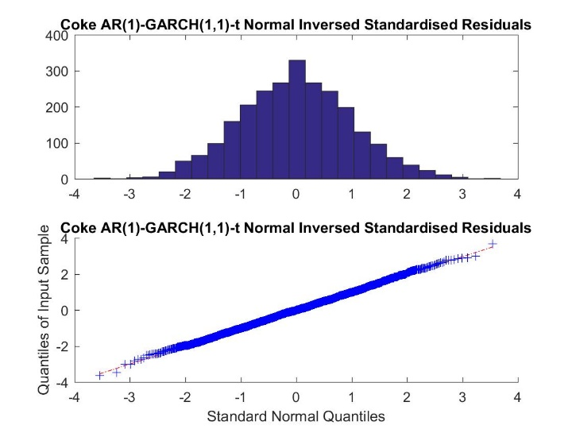

**Figure 12**

Furthermore, JB test is conducted to check if the t-distribution assumption on the errors is satisfied:

The p-value of the test is 0.5000, we therefore do not reject the null hypothesis of normal distribution of the errors and can conclude that the t-distribution assumption on the normal errors is satisfied.

In summary, the model of AR(1)-GARCH(1,1)-t has reasonably well captured the mean and volatility processes of the COKE returns.

* + 1. AR(1)-GJR-GARCH-t Model

The fitting of AR(1)-GJR-GARCH-t model follows the same step as the AR(1)-GARCH-t model. Again, the AIC and SIC suggest the order of (1,1) for the GARCH part of the model. Therefore, we fit a AR(1)-GJR-GARCH(1,1)-t for COKE: (values in the brackets are the standard error)

,

(0.0262) (0.0201)

(0.0353) (0.0194) (0.0399) (0.0252)

All the parameters are significantly different from zero except the constant term in the mean equation and the requirement of stationarity is also met. Low degrees of freedom of 4.53 implies that the tail behavior in the innovations is much heavier than that of Gaussian.

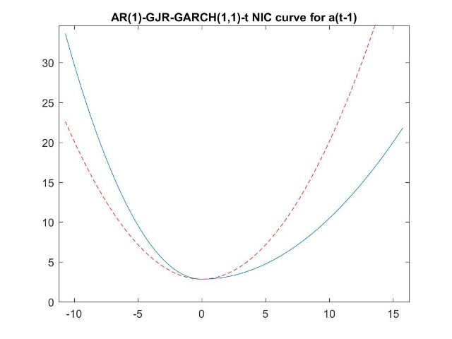

**Figure 13**

**Figure 13** is new impact curve for the AR(1)-GJR-GARCH(1,1)-t. The average volatility in each regime is estimated as:

;

And the volatility persistence in each regime is estimated as:

;

The ratio of negative volatility against positive volatility is estimated as:

The average volatility in negative regime is negative, which indicates infinite volatility and it is also estimated as explosive following negative shocks since the persistence is higher than 1. More than that, volatility is estimated to be 27.68% higher for shocks of -2% compared to those of 2%, indicating very large GJR effects, which leads to significantly strong volatility asymmetry in the asset of COKE.

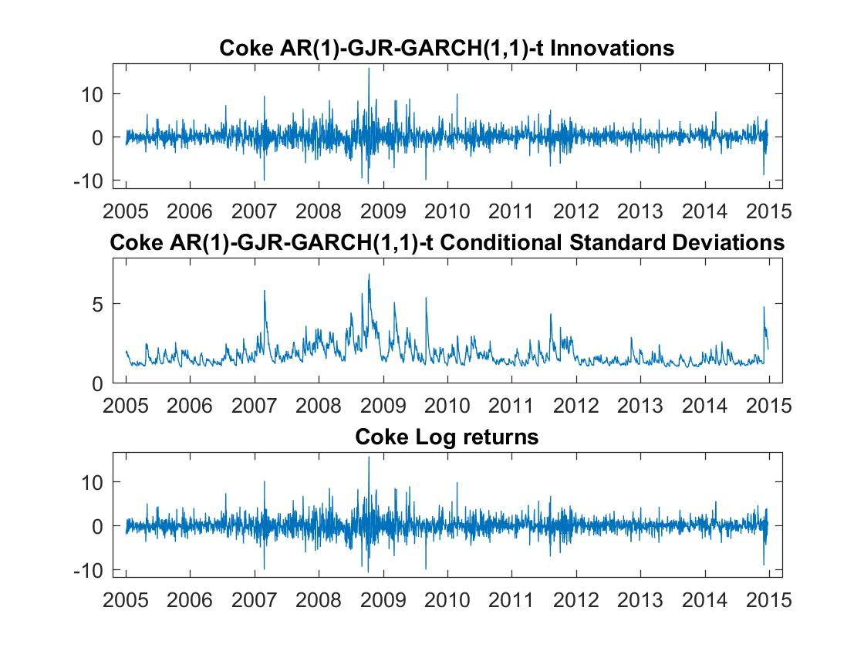

**Figure 14**

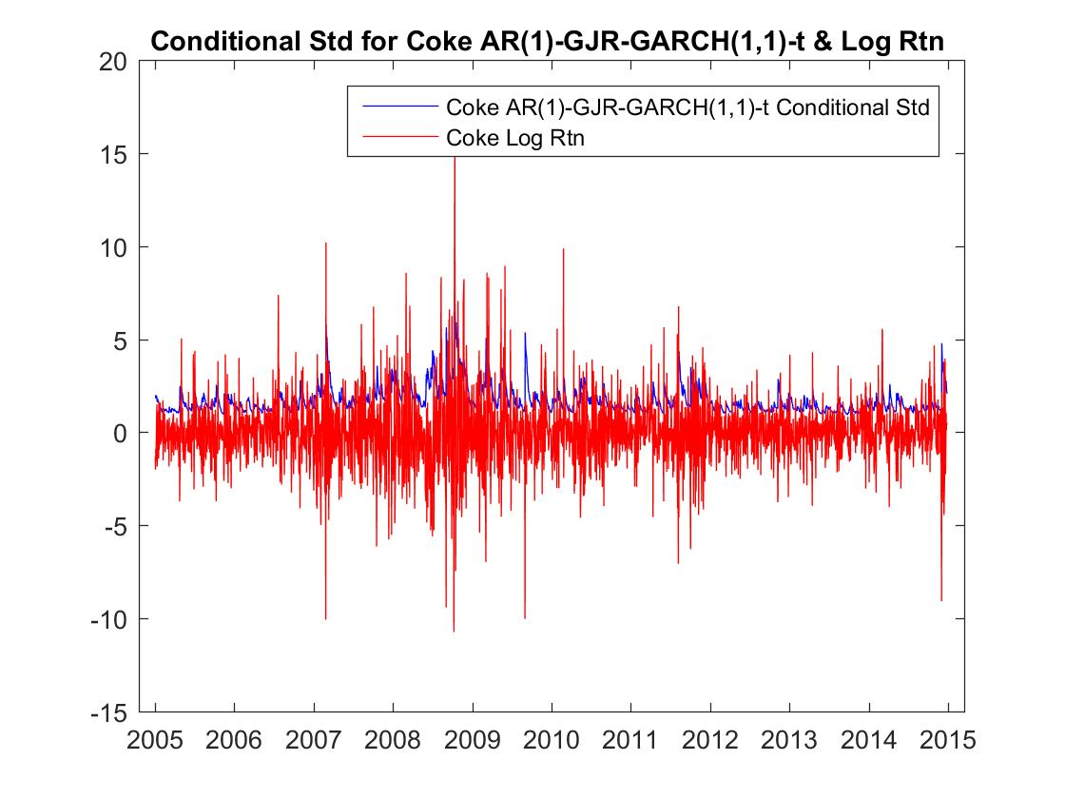

**Figure 15**

**Figure 14** shows the innovations, conditional standard deviation and the log-returns. **Figure 15** plots the conditional standard deviation against the log-returns. As can be seen from the graphs, the conditional standard deviation seems nice and smooth and sits nicely “on the shoulder” of the returns.

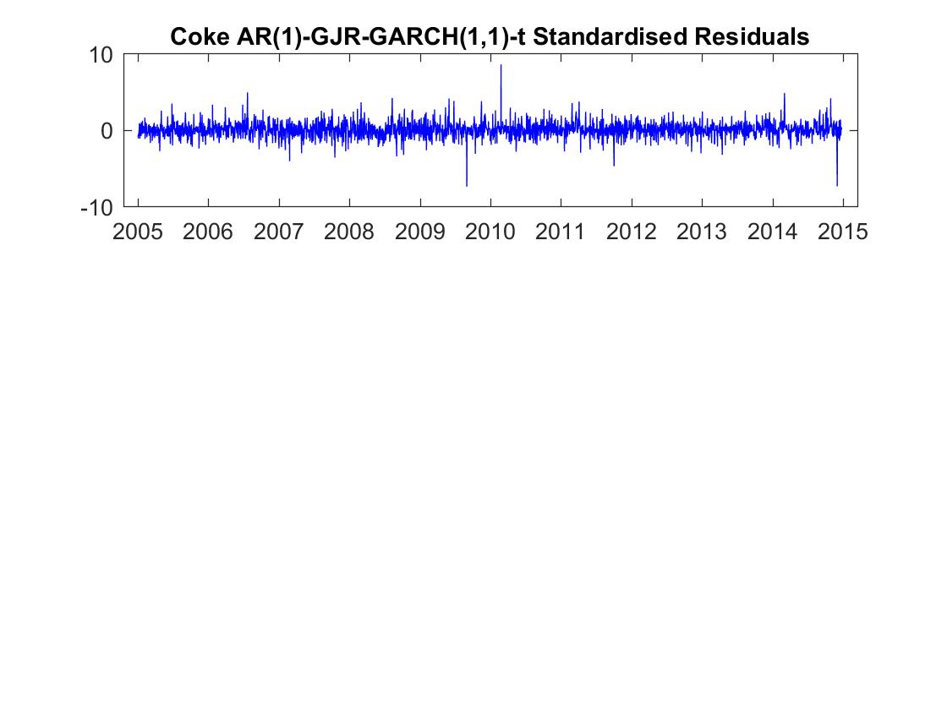

**Figure 16**

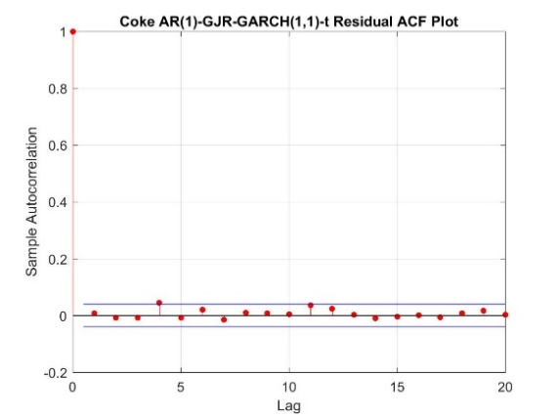 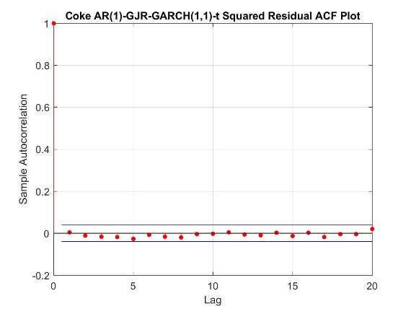

**Figure 17**

The plot of standardised residuals is shown in **Figure 16** together with its ACF and the ACF of the squared residuals. The standardised residuals seem nice and smooth, although with some outliers and appear to show little remaining autocorrelations, which is also true in the squared standardised residuals. These all suggest that both the mean and volatility equations are well specified, which can be verified by the LB test:

|  |  |  |
| --- | --- | --- |
| p-value | m=10, d.f=5 | m=15, d.f=10 |
| Standardized Residuals | 0.0947 | 0.2105 |
| Squared Standardized Residuals | 0.1494 | 0.5305 |

**Table 7**: LB test results on the standardized and squared standardized residuals

All the p-values in the test are greater than 0.05, we therefore do not reject the null hypothesis of no autocorrelations in the standardised and squared standardised residuals, which confirms the conclusion that the mean and volatility equations are well specified.

The histogram of the transformed standardised residuals appears to be more fat-tailed than Gaussian distribution with some outliers. But the qq-plot of both tails do not departure from normality.

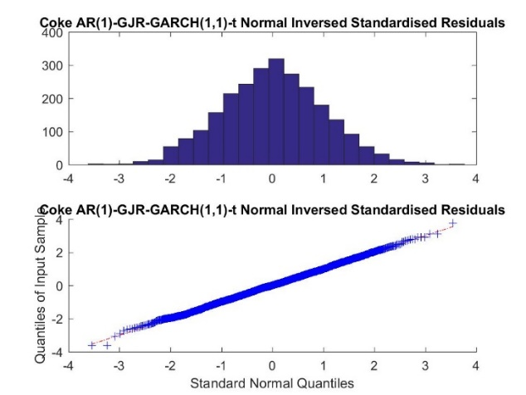

**Figure 18**

The p-value of the JB test is 0.5000, we therefore do not reject the null hypothesis of normal distribution of the transformed errors and can conclude that the t-distribution assumption on the normal errors is satisfied.

In summary, the model of AR(1)-GJR-GARCH(1,1)-t has reasonably well captured the mean and volatility processes of the COKE returns.

### IGARCH(1,1)

This model is only used for analysing and forecasting volatility and it is estimated as:

, where

IGARCH model by its nature has volatility persistence of 1 indicating infinite conditional variance and no mean reversion. The mean equation here is just 0.

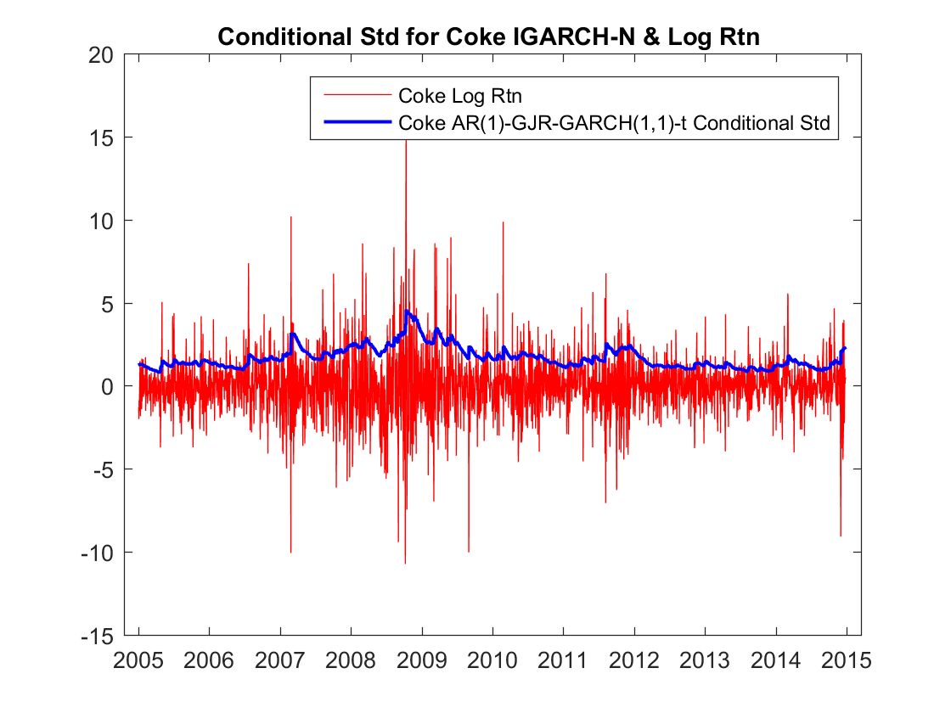

**Figure 19**

**Figure 19**  plots the conditional standard deviation against the log-returns. As can be seen from the graph, the conditional standard deviation seems much smoother than that of the previous two models, which might be the result of its volatility persistence of 1 so that the conditional standard deviation comes back much more slowly.

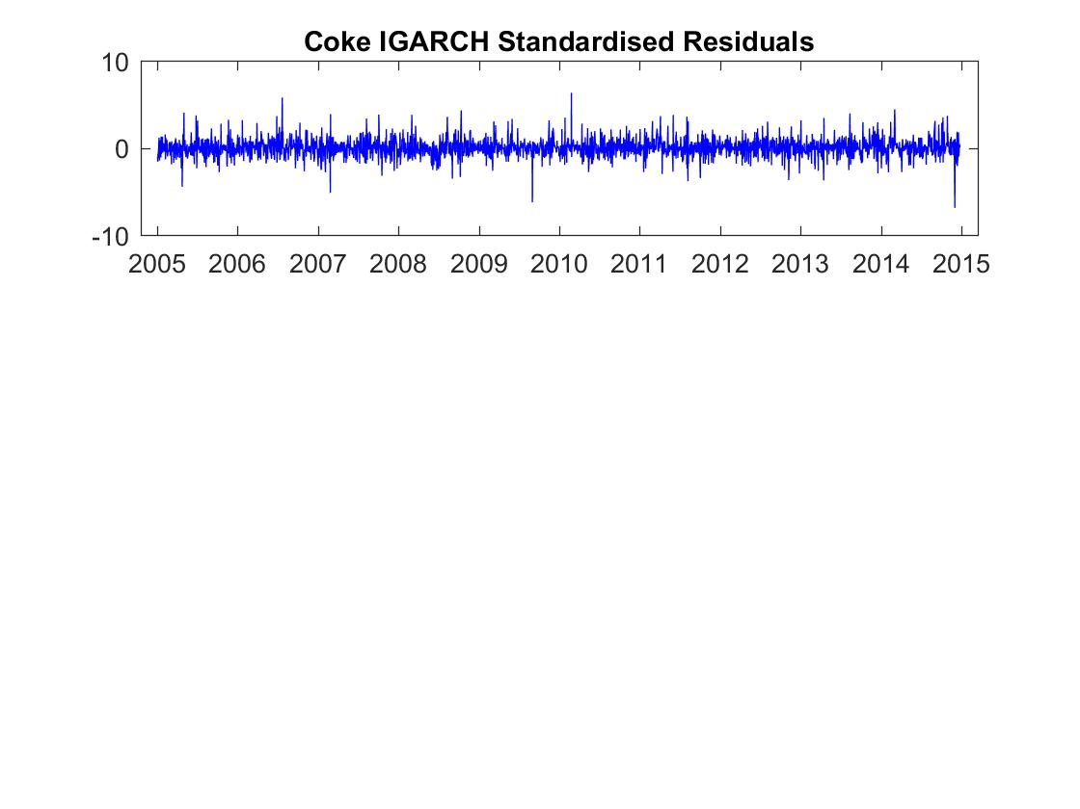

**Figure 20**

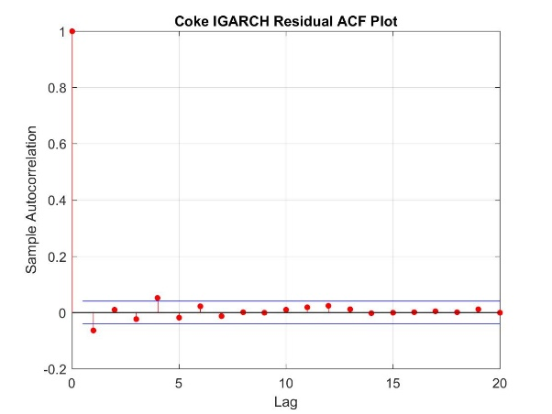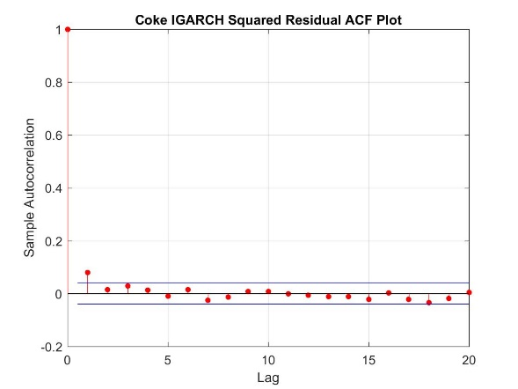

**Figure 21**

The plot of standardised residuals is shown in **Figure 21** together with its ACF and the ACF of the squared residuals. The standardised residuals seem nice and smooth, although with some outliers and it appears to show some remaining autocorrelations, which is also true in the squared standardised residuals. These all suggest that both the mean and volatility equations are not well specified, which can be verified by the LB test:

|  |  |  |
| --- | --- | --- |
| p-value | m=7, d.f=5 | m=12, d.f=10 |
| Standardized Residuals | 0.0008 | 0.0091 |
| Squared Standardized Residuals | 0.0007 | 0.0148 |

**Table 8**: LB test results on the standardized and squared standardized residuals

All the p-values in the test are smaller than 0.05, we therefore reject the null hypothesis of no autocorrelations in the standardised and squared standardised residuals, which confirms the conclusion that the mean and volatility equations are not well specified.

The histogram of the transformed standardised residuals appears to be more fat-tailed than Gaussian distribution with many outliers. The qq-plot of both tails severely departure from normality.

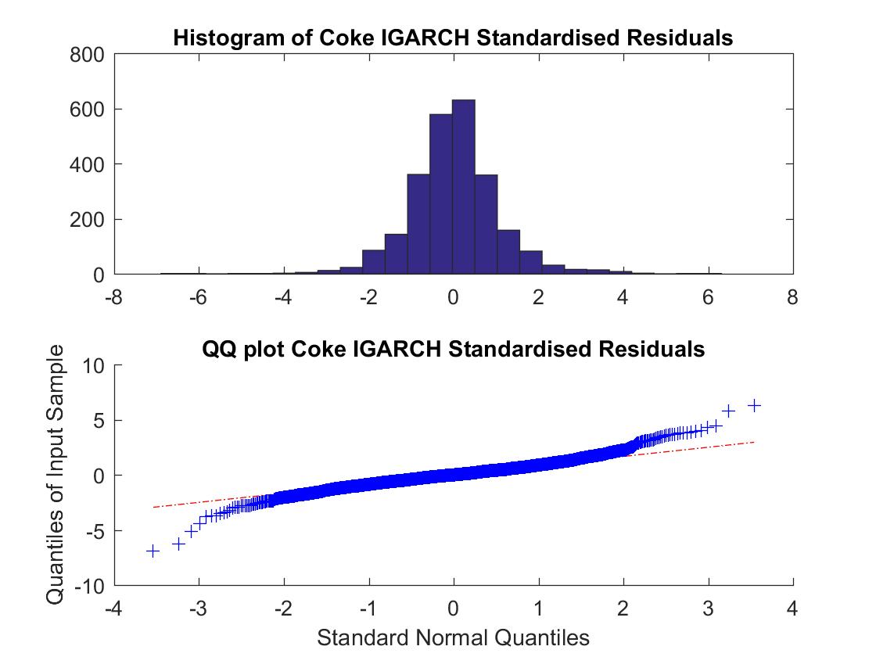

**Figure 22**

The p-value of the JB test is 0.0000, we therefore reject the null hypothesis of normal distribution of the transformed errors and can conclude that the assumption of normal errors is not appropriate for this asset and another distribution of the errors should be assumed.

In summary, the model of IGARCH(1,1) does not capture the mean and volatility processes of the COKE returns. But since it is quite a powerful model in forecasting the volatility, we will leave it as one of the competitive models to forecast the volatility and see how it performs.

### Ad-hoc methods

We have two non-parametric models, which are Historical Simulation with data from the last 25 and 5 days (HS-25 and HS-5), the equation are:

for HS-25,

,

for HS-5,

,

We have two non-parametric models, which are Historical Simulation with data from the last 25 and 5 days (HS-25 and HS-5), the equation are:

for HS-25,

,

for HS-5,

,

## Model Estimation for the Other Assets

The process of estimation and evaluation of the models for the other assets follows the same steps demonstrated above. The equations for the fitted models for each asset are shown below:

|  |  |
| --- | --- |
| **JNJ** | **AR(1)-GARCH(1,1)-t** |
| , 719 assets. o have t-distribution so as to better capture the volatility process the ption on the g ARCH effects in PTR an,  (0.0142) (0.0213)  (0.0091) (0.0202) (0.0231) |
| **AR(1)-GJR-GARCH(1,1)-t** |
| ,  (0.0145) (0.0209)  (0.0082) (0.0156) (0.0346) (0.0211) |
| **IGARCH(1,1)** |
| , where |
| **PTR** | **AR(1)-GARCH(2,2)-t** |
| ,  (0.0602) (0.2231)  (0.0357) (0.01764) (0.0620) |
| **AR(1)-GJR-GARCH(1,1)-t** |
| ,  (0.0343) (0.0208)  (0.0187) (0.0129) (0.0159) (0.0122) |
| **IGARCH(1,1)** |
| , where |
| **MMM** | **AR(1)-GARCH(1,1)-t** |
| ,  (0.0193) (0.0192)  (0.0079) (0.0113) (0.0122) |
| **AR(1)-GJR-GARCH(1,1)-t** |
| ,  (0.0194) (0.0195)  (0.0084) (0.0141) (0.0200) (0.0131) |
| **IGARCH(1,1)** |
| ,where |
| **MSFT** | **AR(1)-GARCH(1,1)-t** |
| ,  (0.0231) (0.0190)  (0.0010) (0.0102) (0.0108) |
| **AR(1)-GJR-GARCH(1,1)-t** |
| ,  (0.0232) (0.0189)  (0.0096) (0.0113) (0.0176) (0.0106) |
| **IGARCH(1,1)** |
| , where |

For the mean equations, all the AR terms are insignificant. However, we still leave them in the models in order to capture the mean processes of the assets and forecast the returns.

In terms of the volatility equations, all the parameters are significant except the leverage term in the AR(1)-GJR-GARCH(1,1) for PTR. For the GARCH-type models, all the volatility persistence is very close to 1, indicating strong persistence in volatility and slow mean reversion in all the assets. For the GJR-type models, all the infinite average volatility following negative shocks and volatility persistence greater than 1 following negative shocks. The ratios are also high among all assets, with the highest of 73.27% for JNJ and the lowest of 7.37% for MSFT. These all suggest that very large GJR effects in the assets, which leads to significantly strong volatility asymmetry. The requirement of stationarity in all GARCH and GJR-GARCH models can be met.

For the IGARCH model, except that it well captures the volatility processes of the MMM assets, for the other assets, it performs as poorly as demonstrated previously in the COKE asset. But we will still leave it as one of the competitive models to forecast the volatility and see how it performs.

We then also conduct LB test and JB test for each of the assets. The results are shown below. We put the test results of the same type of model in the same table in order to see how different types of model perform in different assets.

Table 4 Tests results of the AR-GARCH type models

|  |  |  |  |  |
| --- | --- | --- | --- | --- |
| Tests | JNJ | PTR | MMM | MSFT |
| LB test on standardized residuals | 0.1623(m=9,d.f=5) | 0.1492(m=10,d.f=5) | **0.0178**(m=9,d.f=5) | 0.0705(m=9,d.f=5) |
| 0.1359(m=14,d.f=10) | 0.2684(m=15,d.f=10) | **0.0498**(m=14,d.f=10) | **0.0150**(m=14,d.f=10) |
| LB test on squared standardized residuals | 0.0721(m=9,d.f=5) | 0.1024(m=10,d.f=5) | 0.2105(m=9,d.f=5) | 0.0670(m=9,d.f=5) |
| 0.3009(m=14,d.f=10) | 0.4310(m=15,d.f=10) | 0.0837(m=14,d.f=10) | 0.0969(m=14,d.f=10) |
| JB test on normality of residuals | 0.5000 | 0.5000 | **0.0150** | 0.5000 |

**Table 9**

The LB test results suggest that except for MMM and MSFT, there are no significant remaining autocorrelations effects in the assets and there are no remaining ARCH effects in all the assets.

For the volatility equations, it managed to capture the volatility processes in all the assets while for the mean equations, it failed to capture the autocorrelations in MMM and MSFT, suggesting that a higher order of AR terms is needed. But since the AIC and SIC suggest that AR(1) is the optimal order for these two assets, we did not switch to a higher order, concerning that it might introduce overfitting in the models. Besides, as we are more interested in forecasting the volatility of the assets, we will just leave the original AR(1) in the models.

Generally speaking, AR-GARCH type models perform quite well among all the assets.

|  |  |  |  |  |
| --- | --- | --- | --- | --- |
| Tests | JNJ | PTR | MMM | MSFT |
| LB test on standardized residuals | 0.0512(m=10,d.f=5) | **0.0190**(m=10,d.f=5) | **0.0140**(m=10,d.f=5) | 0.0875(m=10,d.f=5) |
| **0.0298**(m=15,d.f=10) | 0.0593(m=15,d.f=10) | **0.0409**(m=15,d.f=10) | **0.0181**(m=15,d.f=10) |
| LB test on squared standardized residuals | 0.109(m=10,d.f=5) | **0.0093**(m=10,d.f=5) | **0.0218(**m=10,d.f=5) | 0.0662(m=10,d.f=5) |
| 0.4083(m=15,d.f=10) | **0.0007**(m=15,d.f=10) | **0.0435**(m=15,d.f=10) | 0.1184(m=15,d.f=10) |
| JB test on normality of residuals | 0.5000 | 0.5000 | **0.0078** | 0.5000 |

**Table 10:** Tests results of the AR-GJR-GARCH type models

In contrast, AR-GJR-GARCH type models perform much more poorly than AR-GARCH type models. The LB test results suggest that there are significant remaining autocorrelations in all assets and remaining ARCH effects in PTR and MMM. For the volatility equations, it only managed to capture the volatility processes in JNJ and MSFT and for the mean equations, it failed to capture the autocorrelations in all the assets. These suggest that a higher order in AR terms and GARCH terms are needed but since the current orders are chosen based on the results of AIC and SIC, we will leave the same orders in the models.

Moreover, the results of JB test suggest that MMM is the only asset that the t-distribution assumption is not appropriate for its errors. From **Figure 23**, we can see that even after normal transformation, both tails in the qq-plot still severely deviate from normality, which indicates that a different distribution assumption on the errors should be made.

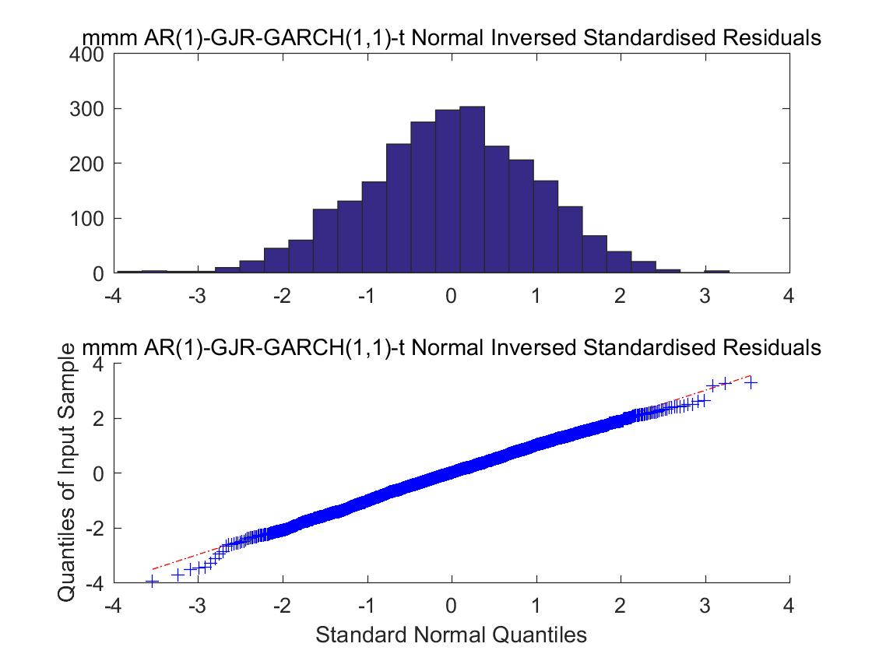

**Figure 23**

The equations of Historical Simulation for the other 4 assets are the same as COKE, which are HS-25 and HS-5.

# Forecast and Accuracy Measures

Based on the parametric, semi-parametric and non-parametric models selected above, we will first implement both one-step ahead and multi-period, including 840-step ahead and 10-step ahead, forecast methods to estimate our underlying assets’ return and volatility (measured by conditional standard deviation) in the selected 840 out of sample period - from 29/12/2014 to 30/04/2018. Then, we will assess the accuracy of return and volatility expectations with the comparison of assets’ daily return and volatility proxies individually. We will focus on analysing one-step ahead and 840-step ahead forecasts in this section since the 10-step ahead forecast is calculated for the purpose of weight optimization in the next sections. For the reason of unmeasurable in reality, true volatilities will be approximated with four commonly used alternatives, which includes the absolute mean corrected daily return and three different range based proxies. The specific expressions of them can be shown as:

Below, one asset will be illustrated in detail and the results of others will be presented in summary.

## Forecast and Volatility Assessment

We will concentrate on the analysis of Coke-Cola (COKE) here and summarize the forecast results of Microsoft (MSFT), Jonson & Jonson (JNJ), 3M (MMM) and Petrol China (PTR).

### Return Forecast and Accuracy Assessment

#### One-Step Ahead Forecast and Assessment

##### Return Forecast

We generate the general forecast results plot for the whole out of sample forecast periods as shown in **Figure 24**, and 50-day Out of sample forecast, started from 12/26/2014, for the convenience of demonstration, seen in **Figure 24**. We can easily see from the two figures below, parametric methods, including AR (1)-GARCH (1,1)-t and AR (1)-GJR-GJR-GARCH (1,1)-t, tend to forecast more smooth and small returns, which are all centred around 0, whereas nonparametric methods’ estimations are more volatile and can well follow the up and down movement of the assets observed returns. However, all of these methods are estimated smaller than COKE’s real returns, which is reasonable, since there will always be uncapturable white noise in our dataset and our models will smooth those noisy part into residual terms.

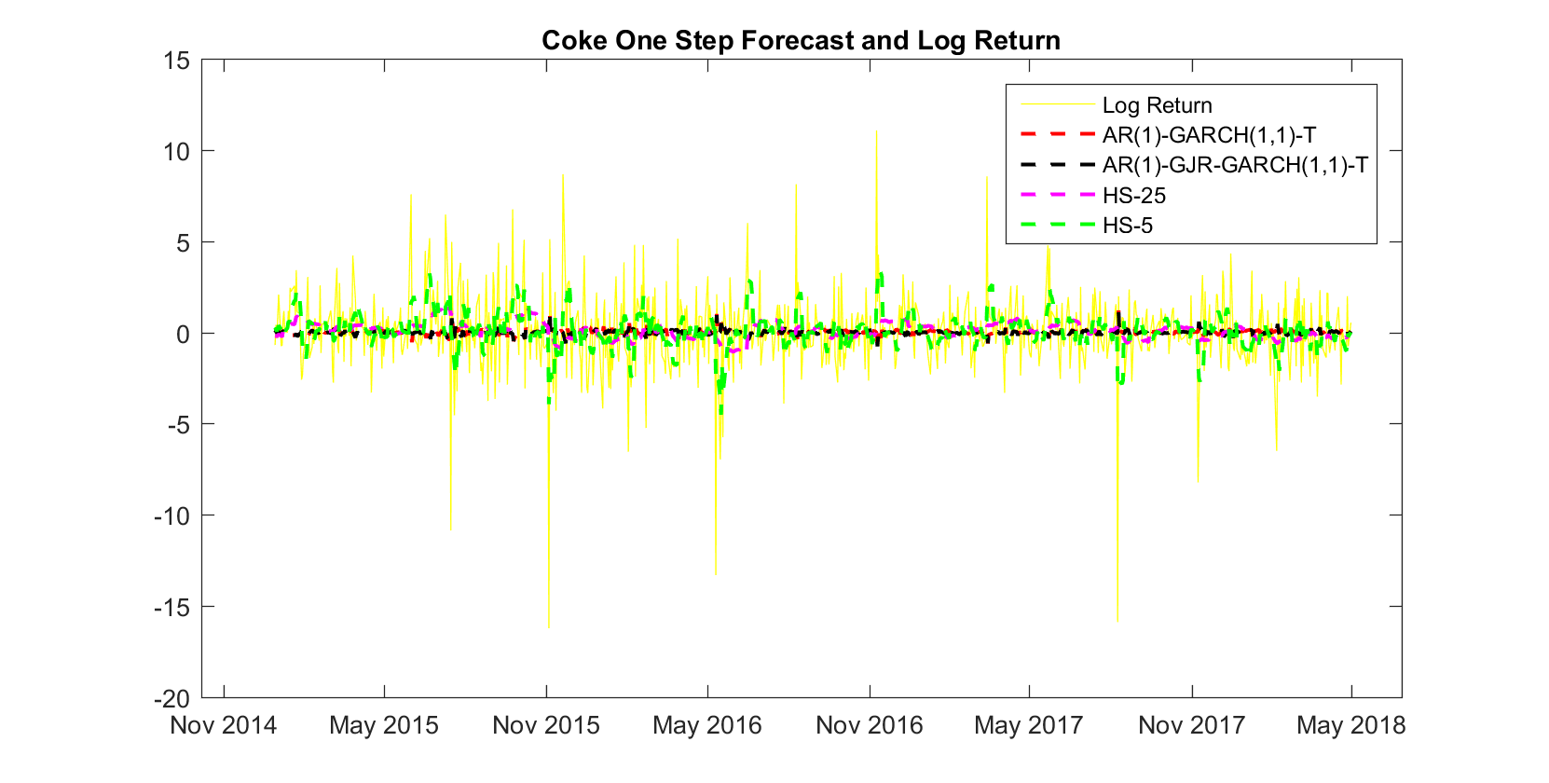

***Figure 24: COKE 840d Out of Sample One-Step Ahead Forecast of four different methods***

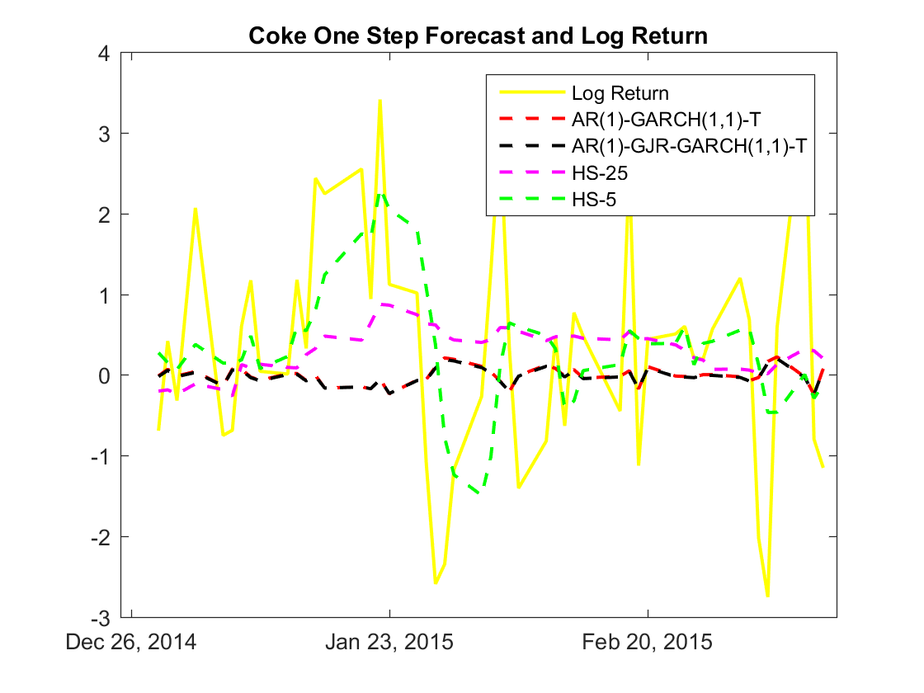

***Figure 25: COKE 50d Out of Sample One-Step Ahead Forecast of four different methods***

##### Accuracy Assessment

We can see from the RMSE and MAD score table, HS-5 method performs the best among others in COKE’s return forecast while AR (1)-GARCH (1,1)-t and HS-25 rank at the bottom in RMSE and MAD measurement separately. Thus, we can conclude that HS-5 selected here have more capability in forecasting returns than others. Combined with the effort and time costed by parametric models, HS-5 are much better choice when generating 1-step return forecast for COKE.

|  |  |  |  |  |
| --- | --- | --- | --- | --- |
| **Accuracy Measurement of COKE One Step Ahead Forecast** | | | | |
|  | **AR (1)-GARCH (1,1)-t** | **AR (1)-GJR-GARCH (1,1)-t** | **HS-25** | **HS-5** |
| RMSE | 2.0802 | **2.0803** | 2.0441 | 1.8428 |
| MAD | 1.3496 | 1.3500 | **1.3503** | 1.2212 |

**Table 11: COKE One Step Ahead Forecast RMSE and MAD Results**

**From Figure 25 and Table 11**, we can find that HS-5 outperforms in every single asset class while AR (1)-GARCH (1,1)-t and AR (1)-GJR-GARCH (1,1)-t rank at the bottom most of the time. Therefore, our conclusion above is confirmed again that HS-5 is more suitable when estimating moving origin fixed horizon 1 return and parametric models perform bad in return estimation. Among all the RMSE and MAD, COKE has the highest error score while MMM has the lowest, and this may relate to the stock’s pattern, such as repeatability, volatility and etc.

|  |  |  |  |  |  |
| --- | --- | --- | --- | --- | --- |
| **Accuracy Measurement of All Assets’ One Step Ahead Forecast** | | | | | |
|  |  | **AR (1)-GARCH (1,1)-t** | **AR (1)-GJR-GARCH (1,1)-t** | **HS-25** | **HS-5** |
| COKE | RMSE | 2.0802 | **2.0803** | 2.0441 | 1.8428 |
| MAD | 1.3496 | **1.3500** | 1.3503 | 1.2212 |
| MSFT | RMSE | 1.4731 | **1.4734** | 1.4460 | 1.3274 |
| MAD | **0.6789** | 0.6787 | 0.6761 | 0.6224 |
| JNJ | RMSE | **0.9546** | 0.9545 | 0.9372 | 0.8600 |
| MAD | 0.9699 | **0.9701** | 0.9724 | 0.8993 |
| MMM | RMSE | **1.0821** | 1.0818 | 1.0552 | 0.9638 |
| MAD | 0.7270 | 0.7268 | 0.7210 | 0.6876 |
| PTR | RMSE | **1.8908** | 1.8902 | 1.8525 | 1.7093 |
| MAD | **1.3764** | 1.3731 | 1.3625 | 1.2686 |

**Table 12: All Assets’ One Step Ahead Forecast RMSE and MAD Results**

|  |  |  |  |  |  |
| --- | --- | --- | --- | --- | --- |
| **Accuracy Measurement of All Assets’ One Step Ahead Forecast** | | | | | |
|  |  | **AR (1)-GARCH (1,1)-t** | **AR (1)-GJR-GARCH (1,1)-t** | **HS-25** | **HS-5** |
| RMSE | COKE | 4 | 3 | 1 | 2 |
| MSFT | 4 | 3 | 1 | 2 |
| JNJ | 4 | 3 | 2 | 1 |
| MMM | 4 | 3 | 2 | 1 |
| PTR | 4 | 3 | 2 | 1 |
| **AVERAGE** | **4** | 3 | 1.6 | 1.4 |
| **MEDIAN** | **4** | 3 | 2 | 1 |
|  | | | | | |
| MAD | COKE | 4 | 1 | 2 | 3 |
| MSFT | 4 | 1 | 2 | 3 |
| JNJ | 4 | 3 | 2 | 1 |
| MMM | 4 | 3 | 2 | 1 |
| PTR | 4 | 3 | 2 | 1 |
| **AVERAGE** | **4** | 2.2 | 2 | 1.8 |
| **MEDIAN** | **4** | 3 | 2 | 1 |

**Table 13: All Assets’ One Step Ahead Forecast RMSE and MAD Rank**

#### Multi-Period Ahead Forecast and Assessment

##### Return Forecast

When estimating 840-step ahead forecast, AR (1)-GARCH (1,1)-t and AR (1)-GJR-GARCH (1,1)-t use the same expectation after step 1, which is the same with our derivation of auto-regressive formula since there is only one lag term in it and thus can only effectively generate one period ahead result based on historical information. HS-25 and HS-5 directly use period 1 results to estimate the whole out of sample periods since no more historical information can be updated into the model after period one. HS-25 generate the lowest return estimation during the whole period compared with other models, which may because of the influence from past relative low returns of COKE.

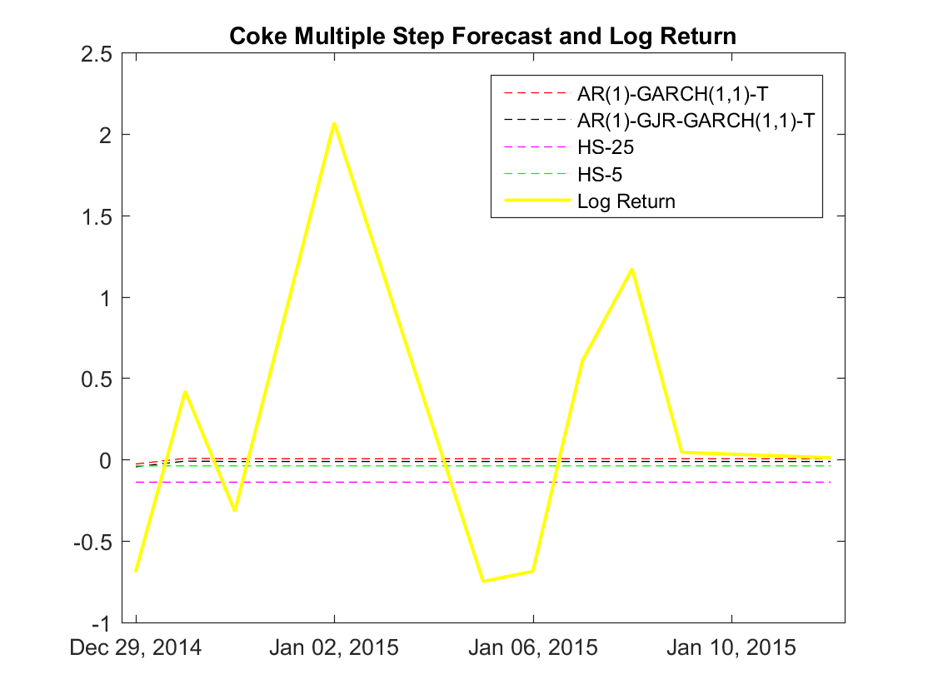

***Figure 26: COKE 50d Out of Sample Multi-Step Ahead Forecast of four different methods***

##### Accuracy Assessment

From the **Figure 26** we can see that AR (1)-GARCH (1,1)-t performs best and HS-5 performs worst, and parametric methods outperform nonparametric methods in COKE 840 step-ahead forecast. But the RMSE and MAD score in COKE forecast are quite high and unacceptable.

|  |  |  |  |  |
| --- | --- | --- | --- | --- |
| **Accuracy Measurement of COKE Multi Step Ahead Forecast** | | | | |
|  | **AR (1)-GARCH (1,1)-t** | **AR (1)-GJR-GARCH (1,1)-t** | **HS-25** | **HS-5** |
| RMSE | 2.0821 | 2.0828 | **2.0922** | 2.0842 |
| MAD | 1.3586 | 1.3591 | **1.3695** | 1.3604 |

**Figure 27: COKE Multi Step Ahead Forecast RMSE and MAD Results**

In **Figure 26 and Figure 27**, AR (1)-GJR-GARCH (1,1)-t model generally performs better, and AR (1)- GARCH (1,1)-t model’s rank is also not bad. However, the nonparametric methods’ forecast results are worse compared with parametric methods, which is the same with COKE’s result. And HS-5 performs worse in most cases. In comparison with one step ahead forecast, we can obviously find that parametric methods are more suitable in long-term forecast than nonparametric methods and multi period ahead forecasts have higher errors than one step ahead forecast. For the general RMSE and MAD values, COKE has the highest RMSE and MAD while JNJ has the lowest, and the lowest rank in multi-step results is not the same with that in one-step table.

|  |  |  |  |  |  |
| --- | --- | --- | --- | --- | --- |
| **Accuracy Measurement of All Assets Multi Step Ahead Forecast** | | | | | |
|  |  | **AR (1)- GARCH (1,1)-t** | **AR (1)-GJR- GARCH (1,1)-t** | **HS-25** | **HS-5** |
| COKE | RMSE | 2.0821 | 2.0828 | **2.0922** | 2.0842 |
| MAD | 1.3586 | 1.3591 | 1.3695 | 1.3604 |
| MSFT | RMSE | 1.4746 | 1.4748 | 1.4783 | 1.4749 |
| MAD | 0.9722 | 0.9723 | 0.9756 | **0.9772** |
| JNJ | RMSE | 0.9553 | 0.9552 | 0.9662 | **1.0219** |
| MAD | 0.6795 | 0.6793 | 0.6922 | **0.7606** |
| MMM | RMSE | 1.0832 | 1.0828 | **1.0929** | 1.0854 |
| MAD | 0.7282 | 0.7280 | **0.7373** | 0.7300 |
| PTR | RMSE | 1.8929 | 1.8924 | 1.8959 | **2.0585** |
| MAD | 1.3806 | 1.3796 | 1.3858 | **1.5867** |

**Figure 28: All Assets’ Multi Step Ahead Forecast RMSE and MAD Results**

|  |  |  |  |  |  |
| --- | --- | --- | --- | --- | --- |
|  | | | | | |
| **Accuracy Measurement of All Assets Multi Step Ahead Forecast** | | | | | |
|  |  | **AR (1)-GARCH (1,1)-t** | **AR (1)-GJR-GARCH (1,1)-t** | **HS-25** | **HS-5** |
| RMSE | COKE | 1 | 2 | 4 | 3 |
| MSFT | 1 | 2 | 4 | 3 |
| JNJ | 2 | 1 | 3 | 4 |
| MMM | 2 | 1 | 4 | 3 |
| PTR | 2 | 1 | 3 | 4 |
| **AVERAGE** | 1.6 | 1.4 | **3.6** | 3.4 |
| **MEDIAN** | 2 | 1 | **4** | 3 |
|  | | | | | |
| MAD | COKE | 1 | 2 | 4 | 3 |
| MSFT | 1 | 2 | 3 | 4 |
| JNJ | 2 | 1 | 3 | 4 |
| MMM | 2 | 1 | 4 | 3 |
| PTR | 2 | 1 | 3 | 4 |
| **AVERAGE** | 1.6 | 1.4 | 3.4 | 3.6 |
| **MEDIAN** | 2 | 1 | 3 | **4** |

**Figure 29: All Assets’ Multi Step Ahead Forecast RMSE and MAD Ranks**

### Volatility Forecasts and Accuracy Assessment

#### One-Step Ahead Forecast and Assessment

##### Volatility Forecast

From the **Figure 30 and 31** below we can see that HS-5’s forecast is most volatile and can well follow the trend, then followed by IGARCH (1,1)-g and two other GARCH type models. IGARCH here reverses slowest in these models because of its non-stationary property. But Compared with those three, HS-25 gives the smoothest results, which is reasonable, since it averages last 25 day’s history return, which is quite long, without diminishing history information by time order.

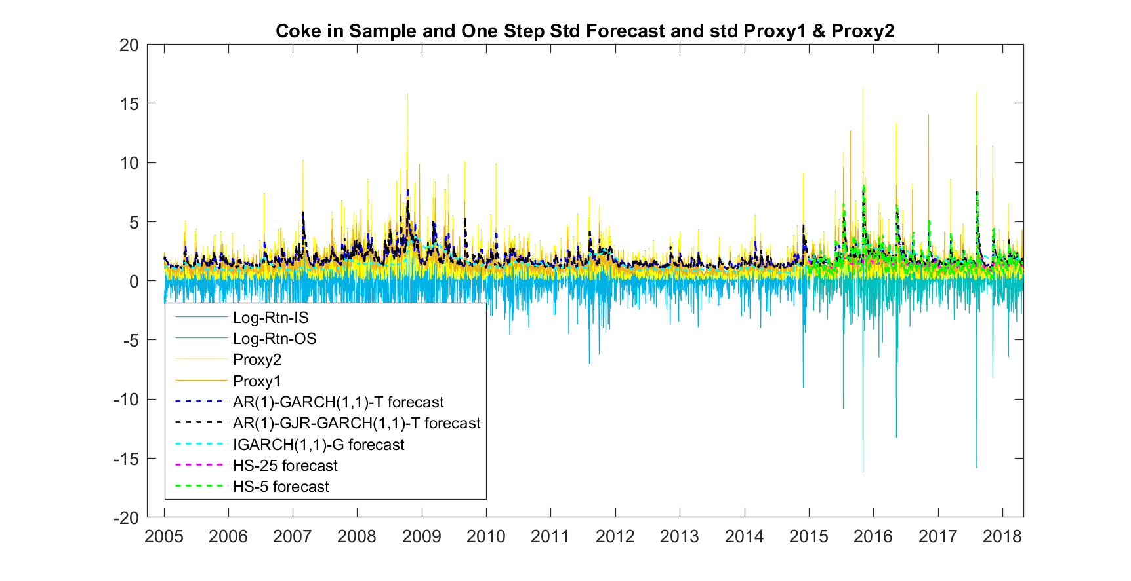

**Figure 30: Coke One Step Ahead in Sample and Out of Sample Forecast Results**

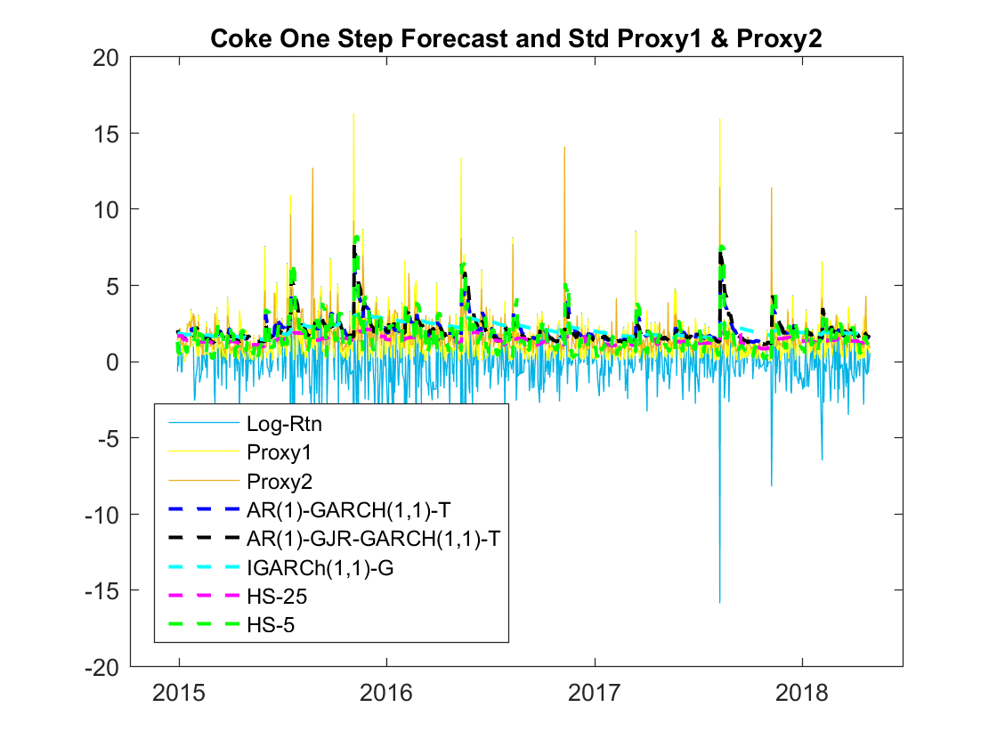

**Figure 31: Coke One Step Ahead Out of Sample Forecast Results**

##### Forecast Assessment

In the Following RMSE and MAD score table, HS-25 performs best, well followed by IGARCH, the semi-parametric model. The two AR-GARCH type models rank at the middle of this chart. And HS-5 ranks at the bottom. COKE generally has the highest RMSE and MAD which may because the return and volatility pattern are hard to capture and this stock is more active than others. The performance of forecast method in one step volatility forecast deviates that in one step return forecast. Since in one step volatility forecast HS-25 performs the best and HS-25 performs worst, while in return forecast HS-5 performs the best and HS-25 performs the worst. The reason for that may because volatility varies a lot, recent volatilities are not good estimate of that in tomorrow, while return changes slower and recent return is a good proxy for near future. Plus, in one-step volatility table, parametric methods rank in the middle while in return forecast, parametric methods’ results are not acceptable. This is also interpretable since GARCH type model is designed for modelling volatility, thus, it is not surprised that they can have better result than in return forecast.

|  |  |  |  |  |  |  |
| --- | --- | --- | --- | --- | --- | --- |
| **Accuracy Measurement of COKE One Step Ahead Forecast** | | | | | | |
|  |  | **AR-GARCH (1,1)-t** | **AR-GJR-GARCH (1,1)-t** | **IGARCH (1,1)-g** | **HS-25** | **HS-5** |
| RMSE | Proxy 1 | 1.7648 | 1.8142 | 1.7271 | 1.5747 | **1.9076** |
| Proxy 2 | 1.3387 | 1.4141 | 1.2718 | 1.2403 | **1.5779** |
| Proxy 3 | 1.4163 | 1.4864 | 1.3518 | 1.4044 | **1.6716** |
| Proxy 4 | 1.4799 | 1.5450 | 1.4173 | 1.5324 | **1.7452** |
| MAD | Proxy 1 | 1.2604 | 1.2670 | **1.2925** | 0.9702 | 1.2508 |
| Proxy 2 | 0.8357 | 0.8576 | 0.8577 | 0.6451 | **0.9341** |
| Proxy 3 | 0.8136 | 0.8356 | 0.8318 | 0.7153 | **0.9596** |
| Proxy 4 | 0.8266 | 0.8505 | 0.8384 | 0.8033 | **1.0007** |

**Figure 32: Coke One Step Ahead Forecast RMSE and MAD Results**

From the general table in **Figure 32** we can see that all assets’ RMSE and MAD behaviours follow the same situation of COKE’s results. HS-25 ranks at the top, IGARCH ranks the second, and AR-GARCH types follows, and then HS-5 has the lowest rank. Thus, we can draw the same conclusion with COKE’s one step ahead volatility forecast and the reason why this pattern exists is quite the same with COKE’s. Except that COKE has the highest RMSE and MAD, JNJ’s RMSE and MAD here is the smallest. Compared with one step RMSE and MAD return summary, the highest ranked stock in volatility table is the same whereas the lowest ranked stock is different.

|  |  |  |  |  |  |  |  |
| --- | --- | --- | --- | --- | --- | --- | --- |
| **Accuracy Measurement of All Assets’ One Step Ahead Forecast** | | | | | | | |
|  |  |  | **AR-GARCH-t** | **AR-GJR-GARCH-t** | **IGARCH-g** | **HS-25** | **HS-5** |
| COKE | RMSE | Proxy 1 | 1.7648 | 1.2133 | 0.6996 | 0.8605 | **1.3492** |
| Proxy 2 | 1.3387 | 1.4141 | 1.2718 | 1.2403 | **1.5779** |
| Proxy 3 | 1.4163 | 1.4864 | 1.3518 | 1.4044 | **1.6716** |
| Proxy 4 | 1.4799 | 1.5450 | 1.4173 | 1.5324 | **1.7452** |
| MAD | Proxy 1 | 1.2604 | 1.2670 | **1.2925** | 0.9702 | 1.2508 |
| Proxy 2 | 0.8357 | 0.8576 | 0.8577 | 0.6451 | **0.9341** |
| Proxy 3 | 0.8136 | 0.8356 | 0.8318 | 0.7153 | **0.9596** |
| Proxy 4 | 0.8266 | 0.8505 | 0.8384 | 0.8033 | **1.0007** |
| MSFT | RMSE | Proxy 1 | 1.2133 | 1.2003 | 1.1789 | 1.1080 | **1.2610** |
| Proxy 2 | 0.7269 | 0.7183 | 0.6703 | 0.5436 | **0.8254** |
| Proxy 3 | 0.8341 | 0.8255 | 0.8053 | 0.7822 | **0.9581** |
| Proxy 4 | 0.6896 | 0.6816 | 0.6581 | 0.6153 | **0.8259** |
| MAD | Proxy 1 | **0.9269** | 0.9055 | 0.8881 | 0.7785 | 0.8586 |
| Proxy 2 | **0.6044** | 0.5854 | 0.5495 | 0.4084 | 0.5523 |
| Proxy 3 | 0.5771 | 0.5571 | 0.5384 | 0.4517 | **0.6012** |
| Proxy 4 | 0.5362 | 0.5206 | 0.5001 | 0.4133 | **0.5693** |
| JNJ | RMSE | Proxy 1 | 0.6996 | 0.7001 | 0.6990 | 0.6998 | **0.7593** |
| Proxy 2 | 0.5149 | 0.5194 | 0.5179 | 0.5232 | **0.5994** |
| Proxy 3 | 0.5467 | 0.5472 | 0.5565 | 0.5619 | **0.6336** |
| Proxy 4 | 0.5670 | 0.5665 | 0.5740 | 0.5815 | **0.6558** |
| MAD | Proxy 1 | 0.5464 | 0.5428 | 0.5391 | **0.5548** | 0.5512 |
| Proxy 2 | 0.3338 | 0.3380 | 0.3228 | 0.3441 | **0.3771** |
| Proxy 3 | 0.3097 | 0.3165 | 0.3071 | 0.3228 | **0.3853** |
| Proxy 4 | 0.3174 | 0.3258 | 0.3139 | 0.3273 | **0.3932** |
| MMM | RMSE | Proxy 1 | 0.8605 | 0.8653 | 0.8262 | 0.8159 | **0.9025** |
| Proxy 2 | 0.5205 | 0.5312 | 0.4673 | 0.4466 | **0.6080** |
| Proxy 3 | 0.5359 | 0.5414 | 0.5108 | 0.5039 | **0.6520** |
| Proxy 4 | 0.4990 | 0.5072 | 0.4724 | 0.4658 | **0.6206** |
| MAD | Proxy 1 | 0.6632 | **0.6640** | 0.6206 | 0.6128 | 0.6189 |
| Proxy 2 | 0.4247 | **0.4268** | 0.3683 | 0.3552 | 0.4105 |
| Proxy 3 | 0.3854 | 0.3857 | 0.3472 | 0.3403 | **0.4231** |
| Proxy 4 | 0.3758 | 0.3786 | 0.3375 | 0.3319 | **0.4214** |
| PTR | RMSE | Proxy 1 | 1.3492 | 1.3448 | 1.3300 | 1.2520 | **1.4597** |
| Proxy 2 | 1.0555 | 1.0514 | 1.0087 | 0.5769 | **1.1080** |
| Proxy 3 | 0.8974 | 0.8868 | 0.8669 | 0.7964 | **1.0362** |
| Proxy 4 | 0.9389 | 0.9322 | 0.8948 | 0.5673 | **1.0240** |
| MAD | Proxy 1 | 1.0837 | 1.0819 | 1.0555 | 0.9213 | **1.1039** |
| Proxy 2 | 0.9465 | **0.9490** | 0.8904 | 0.5001 | 0.8336 |
| Proxy 3 | 0.7309 | 0.7265 | 0.6841 | 0.5472 | **0.7413** |
| Proxy 4 | **0.8172** | 0.8167 | 0.7637 | 0.4576 | 0.7556 |

**Figure 33: Coke One Step Ahead Forecast RMSE and MAD Results**

#### Multi-Period Ahead Forecast and Assessment

##### Volatility Forecast

From the Figure below, we can see that in COKE’s forecast, two AR-GARCH type models and the IGARCH model gives the same level of forecast and are obviously higher than that of HS expectation. This may because the parametric and semi-parametric models stock more historical shock information during in sample model estimation stage, and thus the higher volatility may be influenced by historical shocks. HS methods just use the t+1 forecast to estimate all the out of sample volatilities, while the volatility estimation of GARCH type models marginally diminishing and then maintain the same after around half a year.

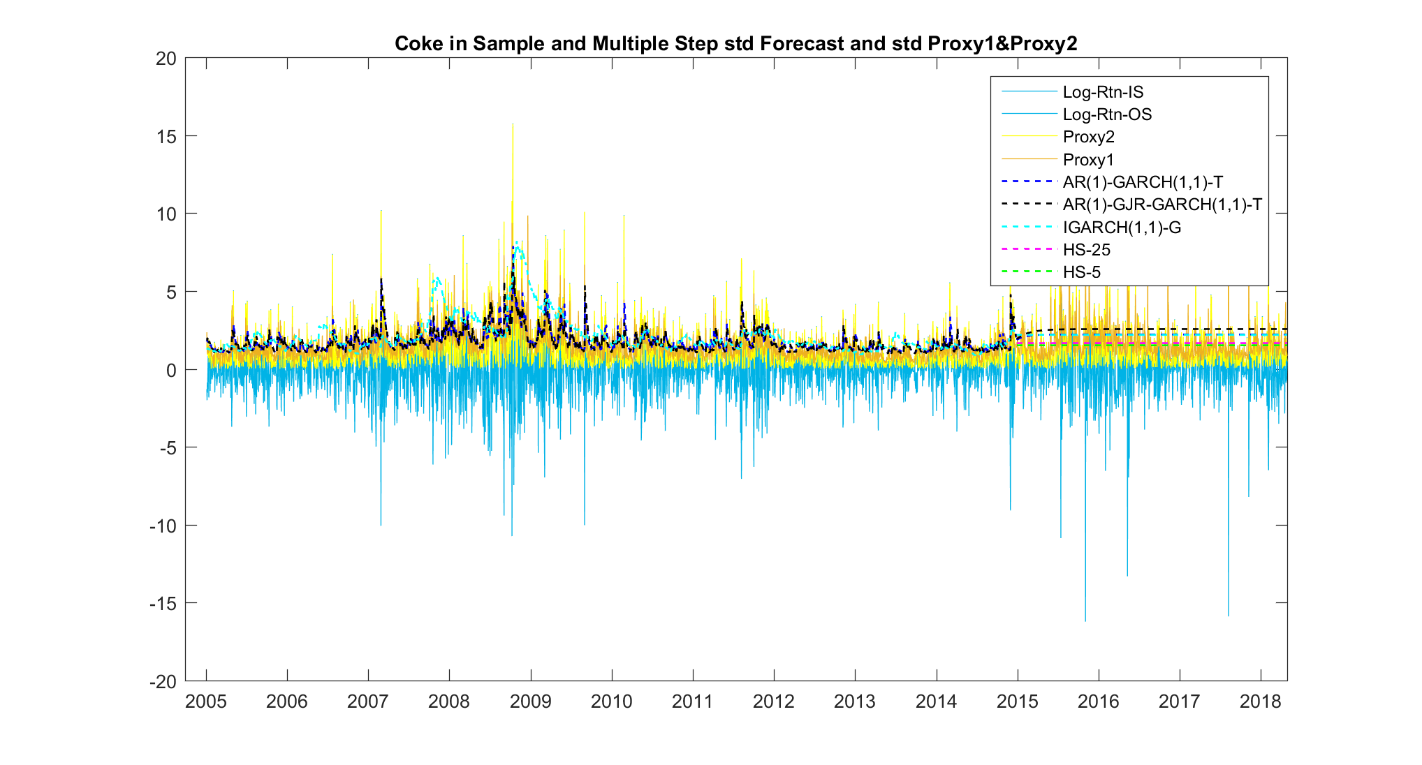

**Figure 34: Coke Multi Step Ahead in Sample and Out of Sample Forecast Results**

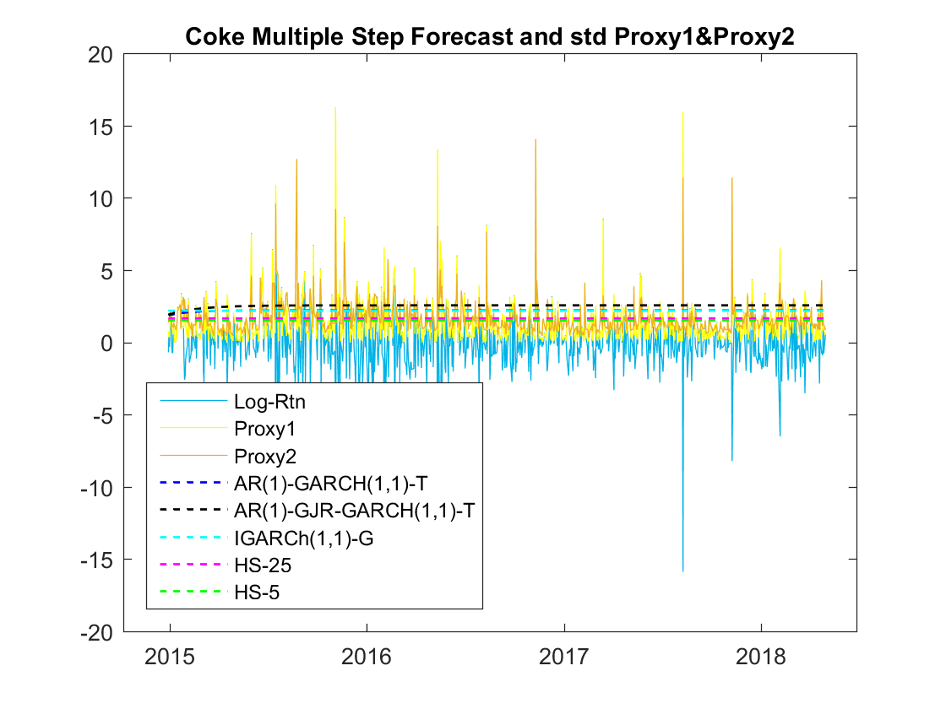

**Figure 35: Coke Multi Step Ahead Out of Sample Forecast Results**

##### Accuracy Assessment

From **Figure 35**, we can see that for COKE the results scatter quite wide, but AR-GJR-GARCH-t model generally performs worst and HS methods have quite good results. The 5 models almost use one average estimation to forecast the following daily volatility in the following 840 trading days, the volatilities in which change a lot day by day, thus, all models’ results may not be believable since long run expectation discard too much information into the residual terms and this may be why the RMSE and MAD score scatter quite random.

|  |  |  |  |  |  |  |  |
| --- | --- | --- | --- | --- | --- | --- | --- |
| **Accuracy Measurement of COKE Multi Step Ahead Forecast** | | | | | | | |
|  |  |  | **AR-GARCH-t** | **AR-GJR-GARCH-t** | **IGARCH-g** | **HS-25** | **HS-5** |
|  | RMSE | Proxy 1 | 1.7841 | **1.9605** | 1.7799 | 1.6047 | 1.5848 |
| Proxy 2 | 1.3343 | **1.5001** | 1.3298 | 1.2188 | 1.2266 |
| Proxy 3 | 1.3986 | **1.5233** | 1.3956 | 1.3544 | 1.3777 |
| Proxy 4 | 1.4572 | **1.5488** | 1.4555 | 1.4653 | 1.4995 |
| MAD | Proxy 1 | 1.3996 | **1.6264** | 1.3918 | 1.1032 | 1.0458 |
| Proxy 2 | 0.9857 | **1.2124** | 0.9771 | 0.7176 | 0.6879 |
| Proxy 3 | 0.9512 | **1.1582** | 0.9435 | 0.7441 | 0.7308 |
| Proxy 4 | **0.9399** | 1.1253 | 0.9335 | 0.7965 | 0.7983 |

**Figure 36: Coke Multi Step Ahead Out of Sample Forecast Results**

From the summary **Figure 36** we can see that the general patterns of all the assets are the same as that of COKE. AR-GJR-GARCH model, or say AR-GARCH type models, perform worst most of the time, and HS methods perform best, and the general patterns are quite scattered. The analysis can also follow that of COKE’S part.

|  |  |  |  |  |  |  |  |
| --- | --- | --- | --- | --- | --- | --- | --- |
| **Accuracy Measurement of COKE Multi Step Ahead Forecast** | | | | | | | |
|  |  |  | **AR-GARCH-t** | **AR-GJR-GARCH-t** | **IGARCH-g** | **HS-25** | **HS-5** |
| COKE | RMSE | Proxy 1 | 1.7841 | **1.9605** | 1.7799 | 1.6047 | 1.5848 |
| Proxy 2 | 1.3343 | **1.5001** | 1.3298 | 1.2188 | 1.2266 |
| Proxy 3 | 1.3986 | **1.5233** | 1.3956 | 1.3544 | 1.3777 |
| Proxy 4 | 1.4572 | **1.5488** | 1.4555 | 1.4653 | 1.4995 |
| MAD | Proxy 1 | 1.3996 | **1.6264** | 1.3918 | 1.1032 | 1.0458 |
| Proxy 2 | 0.9857 | **1.2124** | 0.9771 | 0.7176 | 0.6879 |
| Proxy 3 | 0.9512 | **1.1582** | 0.9435 | 0.7441 | 0.7308 |
| Proxy 4 | **0.9399** | 1.1253 | 0.9335 | 0.7965 | 0.7983 |
| MSFT | RMSE | Proxy 1 | 1.3957 | **1.4363** | 1.1540 | 1.1275 | 1.3132 |
| Proxy 2 | 0.9869 | **1.0413** | 0.6257 | 0.5809 | 0.8736 |
| Proxy 3 | 1.0191 | **1.0606** | 0.8121 | 0.8074 | 0.9355 |
| Proxy 4 | 0.9161 | **0.9633** | 0.6611 | 0.6509 | 0.8199 |
| MAD | Proxy 1 | 1.1788 | **1.2236** | 0.8659 | 0.8163 | 1.0861 |
| Proxy 2 | 0.9056 | **0.9595** | 0.5165 | 0.4511 | 0.7944 |
| Proxy 3 | 0.8495 | **0.8990** | 0.5328 | 0.4956 | 0.7497 |
| Proxy 4 | 0.8082 | **0.8571** | 0.4881 | 0.4530 | 0.7088 |
| JNJ | RMSE | Proxy 1 | 0.7472 | 0.7598 | **0.8829** | 0.7689 | 1.4192 |
| Proxy 2 | 0.5826 | 0.5955 | 0.7240 | 0.6039 | **1.2887** |
| Proxy 3 | 0.6089 | 0.6162 | 0.7080 | 0.6218 | **1.2185** |
| Proxy 4 | 0.6275 | 0.6337 | 0.7170 | 0.6385 | **1.2122** |
| MAD | Proxy 1 | 0.6176 | 0.6336 | 0.7774 | 0.6458 | **1.3302** |
| Proxy 2 | 0.4209 | 0.4396 | 0.6021 | 0.4510 | **1.2200** |
| Proxy 3 | 0.3937 | 0.4080 | 0.5453 | 0.4179 | **1.1274** |
| Proxy 4 | 0.3947 | 0.4079 | 0.5388 | 0.4179 | **1.1114** |
| MMM | RMSE | Proxy 1 | **1.0964** | 0.9868 | 0.8813 | 0.8481 | 0.9712 |
| Proxy 2 | **0.8397** | 0.6975 | 0.5472 | 0.4965 | 0.6760 |
| Proxy 3 | **0.7990** | 0.6821 | 0.5777 | 0.5522 | 0.6647 |
| Proxy 4 | **0.7760** | 0.6547 | 0.5436 | 0.5160 | 0.6360 |
| MAD | Proxy 1 | **0.9628** | 0.8364 | 0.7017 | 0.6519 | 0.8179 |
| Proxy 2 | **0.7776** | 0.6330 | 0.4746 | 0.4148 | 0.6125 |
| Proxy 3 | **0.7080** | 0.5804 | 0.4473 | 0.4014 | 0.5621 |
| Proxy 4 | **0.6960** | 0.5687 | 0.4345 | 0.3903 | 0.5492 |
| PTR | RMSE | Proxy 1 | 1.6123 | 1.5747 | **1.6384** | 1.3296 | 1.3271 |
| Proxy 2 | 1.4734 | 1.4131 | **1.5137** | 0.8830 | 0.8734 |
| Proxy 3 | **1.2744** | 1.2282 | 1.3060 | 0.9156 | 0.9123 |
| Proxy 4 | **1.3558** | 1.2985 | 1.3942 | 0.8206 | 0.8128 |
| MAD | Proxy 1 | 1.4183 | 1.3788 | **1.4454** | 1.0754 | 1.0705 |
| Proxy 2 | 1.3967 | 1.3353 | **1.4376** | 0.8028 | 0.7933 |
| Proxy 3 | 1.1266 | 1.0796 | **1.1587** | 0.7354 | 0.7305 |
| Proxy 4 | 1.2590 | 1.2015 | **1.2976** | 0.7285 | 0.7206 |

**Figure 37: All Assets’ Multi Step Ahead Out of Sample Forecast Results**

## VaR Forecasts and Accuracy

### One-Step Ahead VaR Forecasts

VaR are forecasted under 5 models for all 5 assets, and several tests of violations (number of violations, violation rate, violation rate ratio), independence (independence test, DQ test) and loss function value are performed. Here, we illustrate MSFT in details.

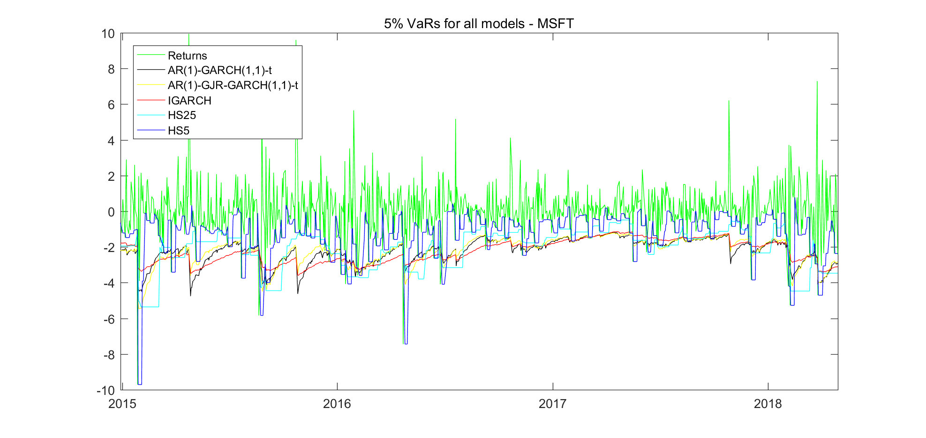

**Figure 38**: VaR Forecasts at 5% for MSFT

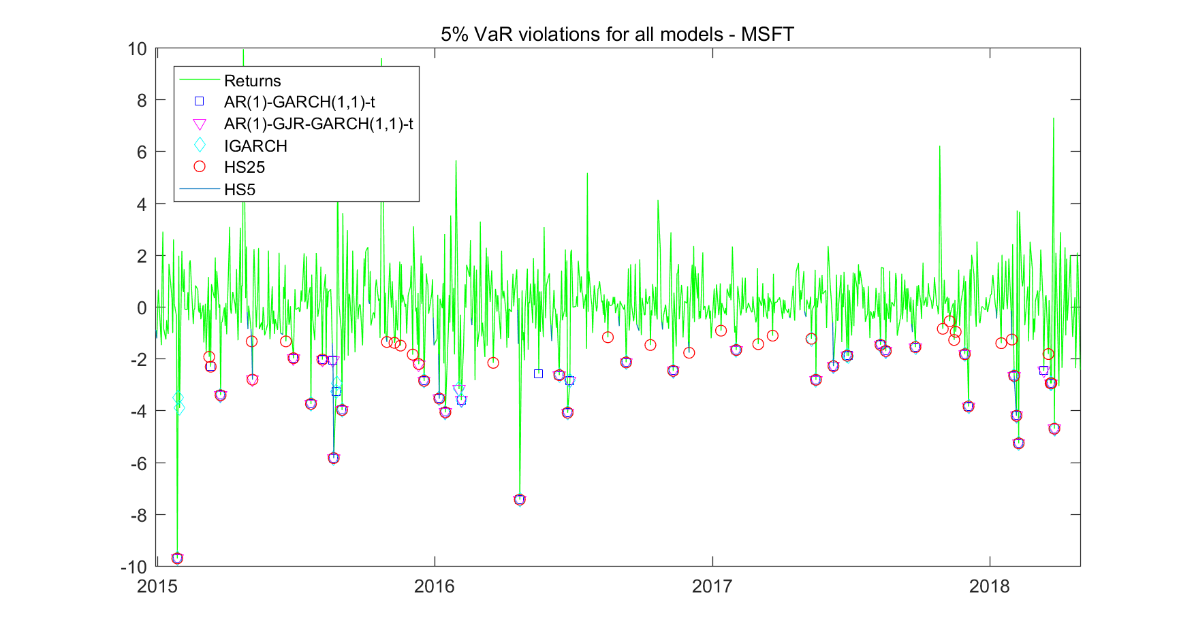

**Figure 39**: Violation at 5% for MSFT

|  |  |  |  |  |  |  |  |
| --- | --- | --- | --- | --- | --- | --- | --- |
| **MSFT** | **AR(1)- GARCH(1,1) -5** | **AR(1)- GARCH(1,1) -10** | **AR(1)-GJR- GARCH(1,1) -5** | **AR(1)-GJR- GARCH(1,1) -10** | **IGARCH** | **HS25** | **HS5** |
| **No of Viols** | 38 | **30** | 37 | **30** | 37 | 55 | 156 |
| **VRate** | 0.05 | **0.04** | 0.04 | **0.04** | 0.04 | 0.07 | 0.19 |
| **VRate Ratio** | 0.90 | **0.71** | 0.88 | **0.71** | 0.88 | 1.31 | 3.71 |
| **CI** | OK **OK** OK **OK** OK NO NO | | | | | | |
| **Ind Test** | 0.00 | 0.03 | 0.10 | 0.40 | 0.00 | **0.73** | 0.71 |
| **DQ Test** | 0.01 | 0.13 | 0.17 | **0.19** | 0.00 | 0.00 | 0.00 |
| **Loss Function** | 139.27 | 138.42 | **137.31** | 138.11 | 140.33 | 149.83 | 187.15 |

**Table 51**: Tests for MSFT

**Figure 38** shows the forecasts of VaR under four models for MSFT compared with its observed log returns. **Figure 39** shows the violations of the VaR forecasts. **Table 38** is a summary of the tests performed for the VaR forecasts.

As can be seen from **Figure 39**, the HS 5 model seems to be most volatile. It has the similar shape with the log return series, which is the model itself is trying to reflect the most recent information quickly. However, it performs the worst in terms of both violation tests and loss function value, which reflects that actually HS 5 is not tracking dynamic risk well just by employing the most recent information. On the contrary, IGARCH is shown to be the most stable one as it does not have significant response to the extreme shocks compared to other models, however, the performance of it in terms of violation rates is intermediate. The violation rate of 0.04 is in between the confidence interval between 0.0353 and 0.0647, thus it is acceptable. The other two GARCH-type models show similar results.

From **Figure 39**, most of the violations are from HS 5 model as we discussed (156 observations as shown in **Table 38**). Also, all model perform well under period when the volatility is low, however, during the February of 2018 when the market was volatile, the models had significantly more violations.

In terms of violation rates compared to Confidence Interval, we expect 95% CI of violation rates to be between 0.0307 and 0.0693 for the two GARCH models with degree of freedom of 5, between 0.0332 to 0.0668 for the two GARCH models with degree of freedom of 10, and between 0.0353 and 0.0647 for other models. All GARCH type models yield results in the interval, however, the 2 HS models do not, which means they underestimate the risks.

The AR(1)-GARCH(1,1) and IGARCH model fails the independence test, which infers that they are not quite reasonable fit. If using more strict DQ test, the 2 HS models are also rejected. Additionally, AR(1)-GJR-GARCH(1,1) model has the lowest loss function, which shows that it is the model to be most close to true VaR.

Overall, the AR(1)-GJR-GARCH(1,1) model is proved to be the best model forecasting VaR, regarding to all our criteria. It has the lowest violations, it also passed both independence test and DQ test, and it has the lowest loss function.

|  |  |  |  |  |  |  |  |
| --- | --- | --- | --- | --- | --- | --- | --- |
| **JNJ** | **AR(1)- GARCH(1,1) -5** | **AR(1)- GARCH(1,1) -10** | **AR(1)-GJR- GARCH(1,1) -5** | **AR(1)-GJR- GARCH(1,1) -10** | **IGARCH** | **HS25** | **HS5** |
| **No of Viols** | 44 | 38 | 49 | 42 | **37** | 55 | 129 |
| **VRate** | 0.05 | 0.05 | 0.06 | 0.05 | **0.04** | 0.07 | 0.15 |
| **VRate Ratio** | 1.05 | 0.90 | 1.17 | 1.00 | **0.88** | 1.31 | 3.07 |
| **CI** | OK OK OK OK **OK** NO NO | | | | | | |
| **Ind Test** | 0.53 | **0.86** | 0.38 | 0.57 | 0.77 | 0.03 | 0.47 |
| **DQ Test** | 0.61 | 0.68 | 0.67 | 0.38 | **0.75** | 0.00 | 0.00 |
| **Loss Function** | 91.33 | 91.35 | **90.07** | 90.20 | 91.12 | 93.03 | 121.51 |

**Table 40**: Tests for JNJ

|  |  |  |  |  |  |  |  |
| --- | --- | --- | --- | --- | --- | --- | --- |
| **KO** | **AR(1)- GARCH(1,1) -5** | **AR(1)- GARCH(1,1) -10** | **AR(1)-GJR- GARCH(1,1) -5** | **AR(1)-GJR- GARCH(1,1) -10** | **IGARCH** | **HS25** | **HS5** |
| **No of Viols** | **5** | **5** | **5** | **5** | 47 | 58 | 142 |
| **VRate** | **0.01** | **0.01** | **0.01** | **0.01** | 0.06 | 0.07 | 0.17 |
| **VRate Ratio** | **0.12** | **0.12** | **0.12** | **0.12** | 1.12 | 1.38 | 3.38 |
| **CI** | **OK OK OK OK** OK NO NO | | | | | | |
| **Ind Test** | **0.807** | **0.807** | **0.807** | **0.807** | 0.163 | 0.315 | 0.127 |
| **DG Test** | 0.000 | 0.000 | 0.000 | 0.000 | **0.218** | 0.000 | 0.000 |
| **Loss Function** | 141.329 | 136.716 | 141.791 | 137.174 | **88.343** | 99.721 | 120.206 |

**Table 41**: Tests for KO

|  |  |  |  |  |  |  |  |
| --- | --- | --- | --- | --- | --- | --- | --- |
| **PTR** | **AR(1)- GARCH(1,1) -5** | **AR(1)- GARCH(1,1) -10** | **AR(1)-GJR- GARCH(1,1) -5** | **AR(1)-GJR- GARCH(1,1) -10** | **IGARCH** | **HS25** | **HS5** |
| **No of Viols** | 39 | 34 | 38 | **33** | 40 | 51 | 133 |
| **VRate** | 0.05 | 0.04 | 0.05 | **0.04** | 0.05 | 0.06 | 0.16 |
| **VRate Ratio** | 0.93 | 0.81 | 0.90 | **0.79** | 0.95 | 1.21 | 3.17 |
| **CI** | OK OK OK **OK** OK OK NO | | | | | | |
| **Ind Test** | 0.05 | 0.14 | 0.18 | 0.03 | 0.16 | 0.95 | **0.21** |
| **DQ Test** | 0.17 | **0.60** | 0.50 | 0.27 | 0.46 | 0.04 | 0.00 |
| **Loss Function** | 160.04 | 159.35 | 160.24 | **159.62** | 160.66 | 170.44 | 231.13 |

**Table 42**: Tests for PTR

|  |  |  |  |  |  |  |  |
| --- | --- | --- | --- | --- | --- | --- | --- |
| **MMM** | **AR(1)- GARCH(1,1) -5** | **AR(1)- GARCH(1,1) -10** | **AR(1)-GJR- GARCH(1,1) -5** | **AR(1)-GJR- GARCH(1,1) -10** | **IGARCH** | **HS25** | **HS5** |
| **No of Viols** | 45 | 42 | 41 | **36** | 40 | 54 | 144 |
| **VRate** | 0.05 | 0.05 | 0.05 | **0.04** | 0.05 | 0.06 | 0.17 |
| **VRate Ratio** | 1.07 | 1.00 | 0.98 | **0.86** | 0.95 | 1.29 | 3.43 |
| **CI** | OK OK OK **OK** OK OK NO | | | | | | |
| **Ind Test** | **0.94** | 0.77 | 0.63 | 0.41 | **0.94** | 0.78 | 0.58 |
| **DQ Test** | **0.22** | 0.22 | 0.72 | 0.26 | 0.21 | 0.00 | 0.00 |
| **Loss Function** | 110.77 | 111.04 | 109.87 | **109.67** | 111.22 | 117.83 | 145.86 |

**Table 43**: Tests for MMM

**Table 40 – Table 43** above show the violation rates and other tests results for the other four assets. As for JNJ, IGARCH overall performs the best, it has the lowest violation rate of 0.04, which is in between of the confidence interval. It also performs best in terms of DQ test, but it has higher loss function values than AR(1)-GJR-GARCH(1,1) model. For KO, the GARCH type models also outperforms the HS models, according to the lower number of violations. However, among all these models, only IGARCH model is not rejected by DQ test to be significantly different from 0.05. For PTR, the AR(1)-GJR-GARCH(1,1) model has the fewest violation, and the lowest loss function value. But, it is rejected by the independence test as it has a p-value below 0.05. Lastly, for MMM, AR(1)-GJR-GARCH(1,1) again proved to be the best model by violation and loss function criteria, it is also not rejected by any independence tests. To conclude, the AR(1)-GJR-GARCH(1,1) model is proved to be the best model among others in terms of forecasting VaR, HS models perform bad, especially during volatile periods. HS 5 always generates the highest violation rates and loss function value.

### Multi-Period VaR Forecasts

**Figure 53** below shows the smoothed VaR with 5% violation rate. The VaR forecasts are more strict and conservative compared to the 1-step forecasts, which largely reduces the violation numbers as well as rates, however, there are occasions when the VaR forecasts become over-estimate the risk level as will be discussed further.

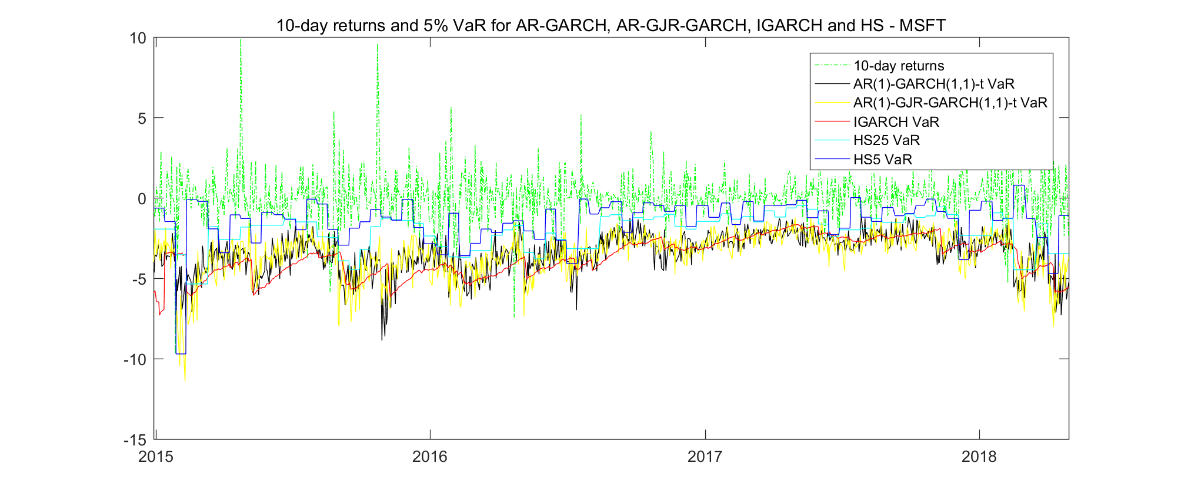

**Figure 53**: VaR Forecasts at 5% for MSFT – 10-step ahead

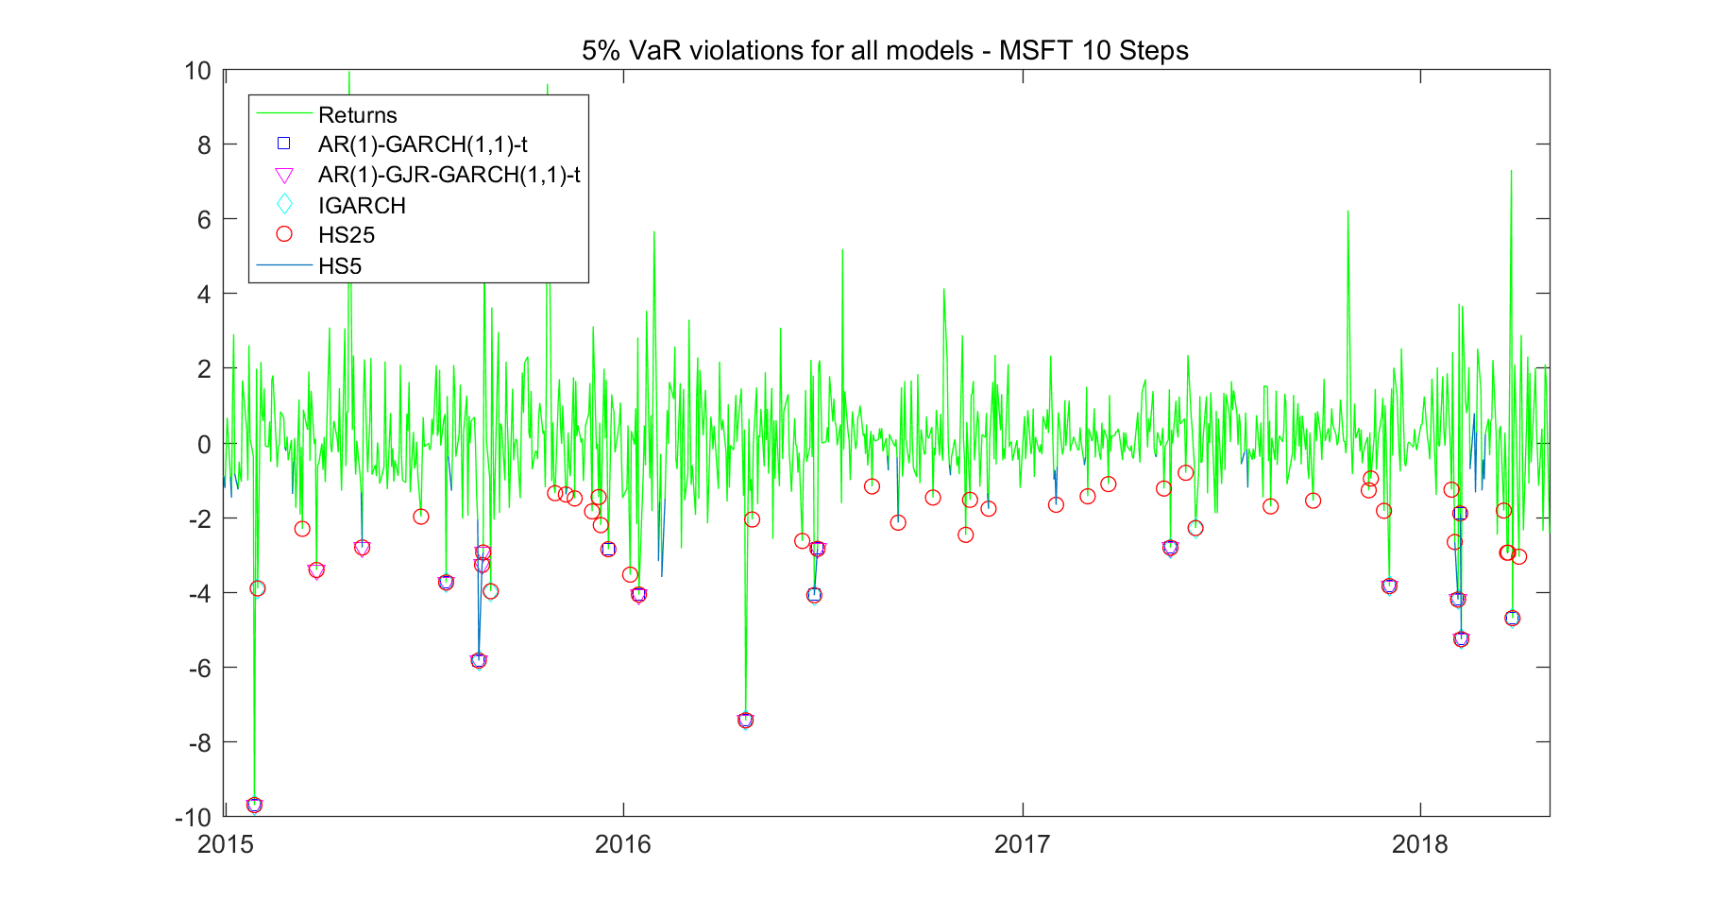

**Figure 54**: Violation at 5% for MSFT – 10-step ahead

|  |  |  |  |  |  |
| --- | --- | --- | --- | --- | --- |
| **MSFT** | **AR(1)- GARCH(1,1) -t** | **AR(1)-GJR- GARCH(1,1) -t** | **IGARCH** | **HS25** | **HS5** |
| **No of Viols** | 16 | 17 | **13** | 54 | 145 |
| **VRate** | 0.02 | 0.02 | **0.02** | 0.06 | 0.17 |
| **VRate Ratio** | 0.38 | 0.40 | **0.31** | 1.29 | 3.45 |
| **CI** | NO NO NO OK NO | | | | |
| **Ind Test** | 0.00 | 0.35 | **0.52** | 0.18 | 0.02 |
| **DQ Test** | 0.00 | 0.00 | 0.00 | 0.00 | 0.00 |
| **Loss Function** | 174.84 | 174.22 | 178.31 | **154.29** | 190.03 |

**Table 56**: Tests for MSFT – 10-step ahead

According to **Figure 53**, again the HS 5 model is the most dynamic one, with the risk of yielding more violations. During period of low volatilities, only HS 5 yielded violations quite frequently among these models. The AR(1)-GJR-GARCH(1,1) and AR(1)-GARCH(1,1) also shows the similar lines very close to each other. IGARCH performs most consistent during both periods of high volatility and low volatility, and its forecast line in **Figure 53** is below the other lines and thus has the smallest number of violations.

As from Table 56, IGARCH performs best in terms of number of violations (13), with violation rate of 0.02, which is however not expected according to the confidence interval. None of those models survives the relatively strict DQ test, with p-values of 0, even though some of them passed the independence test. Unfortunately, the lowest loss function for 10-step ahead forecasts belongs to HS 25 model, thus here our advanced quantitative models did not outperform the much straight-forward HS.

Other Models:

|  |  |  |  |  |  |
| --- | --- | --- | --- | --- | --- |
| **JNJ** | **AR(1)- GARCH(1,1) -t** | **AR(1)-GJR- GARCH(1,1) -t** | **IGARCH** | **HS25** | **HS5** |
| **No of Viols** | 25 | 24 | **14** | 60 | 148 |
| **VRate** | 0.03 | 0.03 | **0.02** | 0.07 | 0.18 |
| **VRate Ratio** | 0.60 | 0.57 | **0.33** | 1.43 | 3.52 |
| **CI** | OK OK NO NO NO | | | | |
| **Ind Test** | 0.21 | **0.18** | 0.02 | 0.00 | 0.00 |
| **DQ Test** | **0.10** | 0.02 | 0.00 | 0.00 | 0.00 |
| **Loss Function** | 102.86 | 106.82 | 117.73 | **97.70** | 129.66 |

**Table 57**: Tests for JNJ – 10-step ahead

|  |  |  |  |  |  |
| --- | --- | --- | --- | --- | --- |
| **KO** | **AR(1)- GARCH(1,1) -t** | **AR(1)-GJR- GARCH(1,1) -t** | **IGARCH** | **HS25** | **HS5** |
| **No of Viols** | **2** | **2** | 15 | 56 | 134 |
| **VRate** | **0.00** | **0.00** | 0.02 | 0.07 | 0.16 |
| **VRate Ratio** | **0.05** | **0.05** | 0.36 | 1.33 | 3.19 |
| **CI** | NO NO NO NO NO | | | | |
| **Ind Test** | **0.92** | **0.92** | 0.26 | 0.01 | 0.00 |
| **DQ Test** | 0.00 | 0.00 | 0.00 | 0.00 | 0.00 |
| **Loss Function** | 216.43 | 221.85 | 107.88 | **100.77** | 128.66 |

**Table 58**: Tests for KO – 10-step ahead

|  |  |  |  |  |  |
| --- | --- | --- | --- | --- | --- |
| **PTR** | **AR(1)- GARCH(1,1) -t** | **AR(1)-GJR- GARCH(1,1) -t** | **IGARCH** | **HS25** | **HS5** |
| **No of Viols** | 21 | 13 | **7** | 48 | 126 |
| **VRate** | 0.03 | 0.02 | **0.01** | 0.06 | 0.15 |
| **VRate Ratio** | 0.50 | 0.31 | **0.17** | 1.14 | 3.00 |
| **CI** | OK NO NO OK NO | | | | |
| **Ind Test** | 0.55 | 0.19 | **0.73** | 0.02 | 0.00 |
| **DQ Test** | 0.02 | 0.00 | 0.00 | 0.01 | 0.00 |
| **Loss Function** | 197.70 | 201.35 | 219.07 | **169.42** | 215.14 |

**Table 59**: Tests for PTR – 10-step ahead

|  |  |  |  |  |  |
| --- | --- | --- | --- | --- | --- |
| **MMM** | **AR(1)- GARCH(1,1) -t** | **AR(1)-GJR- GARCH(1,1) -t** | **IGARCH** | **HS25** | **HS5** |
| **No of Viols** | 30 | 30 | **13** | 54 | 146 |
| **VRate** | 0.04 | 0.04 | **0.02** | 0.06 | 0.17 |
| **VRate Ratio** | 0.71 | 0.71 | **0.31** | 1.29 | 3.48 |
| **CI** | OK OK NO OK NO | | | | |
| **Ind Test** | **0.94** | **0.94** | 0.52 | 0.77 | 0.01 |
| **DQ Test** | 0.15 | **0.23** | 0.00 | 0.00 | 0.00 |
| **Loss Function** | 124.03 | 121.58 | 133.07 | **119.24** | 158.98 |

**Table 60**: Tests for MMM – 10-step ahead

According to **Table 57 – Table 60** above, the IGARCH model performs the best for JNJ, PTR, and MMM in terms of accuracy, since they yield the smallest number of violations. The AR(1)-GJR-GARCH(1,1)-t model is most accurate in forecasting for KO, with only 2 violations. However, regarding to the independence test and DQ test, these models struggled to passed them, which indicates they might not be reasonable fit. The advanced quantitative models are all shown to have larger loss function value than the HS 25 model, which suggests that the GARCH models are not tracking dynamic risks better than the HS 25.

# Optimal Portfolio Allocation Strategy

Portfolio management plays an important role in finance since building portfolio can get benefit of diversification which reduces volatility by combining individual assets. More specifically, individual assets have their idiosyncratic risk due to operating conditions of their companies or industries. By combining these individual assets together, the fluctuations of returns in the opposite direction would cancel each other out, thus the fluctuation of portfolio would be smoothed.

When doing portfolio management, the main task is to assign weights for individual assets.

There are a lot of methods assigning weights and the most famous one is the Markowitz portfolio theory which focuses on building portfolio to minimize variance. In the following parts, weighting methods without adjustment and with 1-period and 5-period adjustment are discussed and we also gives several ways of assigning weights: equal weighting, weighing based on returns, volatility, and value at risk (VaR) in fixed and dynamic approach.

1. Weight assigning methods

First of all, the simplest way is to assign equal weight to each individual asset. Although equal weighting is very easy to understand and implement, it often outperform complex weighting methods. Therefore it is used as benchmark in our analysis. the equal weighting method would not change weights assigned in fixed or dynamic weight adjusting approach, so equal weighting is discussed at the beginning. In our case, there are five stocks considered. Hence, we assign 1/5 to each stocks and the portfolio return is equal to:

Where is the portfolio return at time t which is the weighted average of five stocks returns at time t with equal weights 1/5.

For weighting method based on returns, we assign higher weight to stocks having higher returns at time t being proportional to sum of stocks returns at time t. This strategy focuses on returns only and might be suitable for risk neutral investors who do not care about risks.

Volatility strategy aims to minimize risk (volatility) by assigning higher weight to stocks having lower volatility. Hence, reciprocal of volatility is used in computation of weights. This strategy is more in line with our intuition of portfolio management, since majority of investors are risk-averse and attach great importance to risks.

Value at risk (VaR) calculated by percentiles is a widely used risk measure showing the maximal loss of invested assets that may occur during a given time period and at a given probability level(Tsay, 2010). VaR showing possible extreme loss is more conservative than volatility. Thus, we considered a portfolio strategy which has similar weights calculation process with volatility strategy except for using reciprocal of VaR instead of reciprocal of volatility. In other words, we assign higher weight to assets with lower VaR.

1. Dynamic adjustment

When doing portfolio allocation, we usually adjust weights periodically. Returns, volatility, value at risk and other portfolio allocation criteria like betas are dynamic, so weights have to be dynamically adjusted. However, adjusting weights with high frequency has very high cost while lower frequency cannot catch changes of these investment criteria and might lead to large loss. Thus, there is a trade-off when we are considering adjustment frequency. In the following part, we discussed two frequencies—adjust weights every one period and every five period.

* Adjust weights every period

Comparing with computational costs of portfolio allocation with high frequency (every second, minute, etc), adjusting weight every day has reasonable costs and can capture market changes timely to avoid great losses in most cases.

Formulas of rebalancing weights are shown as follow:

|  |  |  |  |
| --- | --- | --- | --- |
| Strategy according to: | Return | Volatility | Value at Risk |
|  |  |  |  |

Table 1 Dynamic adjustment—1 period frequency

In Table 1, is the weight for stock *i* (*i*=1,2,…,5) at time t. denotes one-step ahead return forecasted at time t for stock *i,*  is the one-step ahead volatility forecast on origin t for stock *i* and is the one-step ahead value at risk forecast on origin t for stock *i*. The denominator ensures that the sum of the calculated weights is 1, but there is no constraint of short selling.

* Adjust weight every ten periods

Rebalancing portfolio every ten days reduces ability to capture market movements comparing with daily adjustment. However, lower the frequency, lower the costs. If the stock has less volatile returns, adjusting weights once every ten days is a reasonable choice.

Formulas of weights re-calculation is given as follow:

|  |  |  |  |
| --- | --- | --- | --- |
| Strategy according to: | Return | Volatility | Value at Risk |
|  |  |  |  |

Table 2 Dynamic adjustment—5 periods frequency

In Table 2, capital T is equal to t+1, t+2, …, t+10 where t is the forecast origin. Thus, is the weight assigned to stock *i* at time T. , , are the j-step ahead forecasts for return, volatility and value at risk for stock i with origin time t (j=1,2,…,10). More specifically, For example, at origin t, we forecast one-step, two-step,…, ten-step ahead returns which are denoted as , then we move to t+10 and use t+10 as new forecast origin to forecast the next 10 steps, and so on.

* Potential problems of these weighting methods.

Although these portfolio weighting strategies are very intuitive and commonly used, there are some problems that should be presented. First of all, for return method, it is possible for the denominator of weighting formula being equal to zero or close to zero. As a result, weights assigned can have extreme values since there is no constraint about positions. Allocating portfolio weights by VaR strategy also causes problems. It is unlikely to have VaR valued at 0 since VaR measures possible extreme loss when rare bad events happen. However, when implementing historical simulations, the probability of having VaR being equal to 0 is very low but can still be greater than zero especially for short-term historical simulations.

1. Assessing portfolios under different models

Since equal weighting method does not change weights assigned according to forecast results, the realized mean and standard deviation of portfolio would not vary when changing models. Results of different weighting strategies are shown and discussed in the following part.

* Portfolio rebalanced every one period

|  |  |  |  |  |  |  |  |  |
| --- | --- | --- | --- | --- | --- | --- | --- | --- |
| 1-period dynamic | Return Strategy | | Volatility Strategy | | VaR Strategy | | Equal Weight | |
| (%) | mean | std | mean | std | mean | std | mean | std |
| AR-GARCH | 0.2092 | 9.3195 | 0.0286 | 0.8649 | 0.0224 | 0.8755 | 0.0139 | 0.9089 |
| AR-GJR-GARCH | 0.1935 | 9.2856 | 0.0241 | 0.8634 | 0.0199 | 0.8748 | 0.0139 | 0.9089 |
| IGARCH | NAN | NAN | 0.0306 | 0.8736 | 0.0203 | 0.8319 | 0.0139 | 0.9089 |
| HS25 | **-0.2078** | 14.5094 | 0.0224 | 0.8770 | 0.0194 | 0.8404 | 0.0139 | 0.9089 |
| HS5 | **0.2563** | 13.6839 | 0.0137 | 0.9148 | 0.0065 | 1.7449 | 0.0139 | 0.9089 |

Table 3 Portfolio performance with 1-period dynamic adjustment

As shown by Table 3, for portfolios rebalanced every one period, the highest return is 0.2563% achieved by return strategy under HS5 model while the lowest (-0.2078%) comes from HS25. The second and third highest returns are also generated through return strategy. The reason might be that return strategy always tends to allocate high weight to stocks with high returns forecasted at rebalancing day, and assigning weights without having constraint may generate extreme position for the dominator of return strategy formula can be close to zero. Since IGARCH model cannot forecast returns, we have no valid portfolio weight generated by return strategy. As for volatility strategy, portfolio allocated through IGARCH model has the highest return: 0.0306% and the lowest is 0.0137% generated by HS5. Portfolios weighting by VaR forecasts from AR-GARCH and IGARCH model have the 1st and 2nd highest returns being 0.0224% and 0.0203% respectively. The lowest return is again yield by HS5 model.

The standard deviation calculated for portfolios can be seen as measure of risk. As expected, portfolios formed by return strategy suffer from high risk which is at least ten times as high as risk of portfolios formed by volatility or VaR strategy. Volatility-strategy-weighted and VaR-strategy-weighted 1-period dynamic portfolios have similar risk. Portfolios weighted by forecasts from AR-GJR-GARCH and IGARCH have the lowest risk (0.8634% and 0.8319%) when implementing volatility strategy and VaR strategy respectively. Weighting by volatility and VaR strategy, daily rebalanced portfolio constructed by HS5 has the highest risk: 0.9148% for volatility strategy and 1.7449% for VaR strategy.

Overall, most of daily rebalanced portfolios formed by the first three strategies outperform our benchmark which is equally weighted portfolio except for HS5, which has lower return and higher risk than benchmark portfolio under volatility and VaR strategy.

* Portfolio rebalanced every ten periods

|  |  |  |  |  |  |  |  |  |
| --- | --- | --- | --- | --- | --- | --- | --- | --- |
| 10-period dynamic | Return Strategy | | Volatility Strategy | | VaR Strategy | | Equal Weight | |
| (%) | mean | std | mean | std | mean | std | mean | std |
| AR-GARCH | 0.0045 | 1.1571 | 0.0247 | 0.8595 | 0.0193 | 0.8780 | 0.0139 | 0.9089 |
| AR-GJR-GARCH | 0.0089 | 1.0426 | 0.0253 | 0.8602 | 0.0200 | 0.8792 | 0.0139 | 0.9089 |
| IGARCH | NAN | NAN | 0.0257 | 0.8726 | 0.0181 | 0.8309 | 0.0139 | 0.9089 |
| HS25 | **-0.1373** | 5.6555 | 0.0208 | 0.8615 | 0.0219 | 0.8407 | 0.0139 | 0.9089 |
| HS5 | **0.2025** | 3.1194 | 0.0276 | 0.8076 | 0.0089 | 1.0379 | 0.0139 | 0.9089 |

Table 4 Portfolio performance with 10-period dynamic adjustment

Re-allocating portfolio weights by return method every ten periods yields the highest return 0.2025% under HS5 and then lowest return -0.1373% under HS25. However, unlike 1-day dynamic adjustment, for AR-GARCH and AR-GJR-GARCH, using return strategy generates lower returns than using other strategies. By implementing volatility strategy, HS5 is the one that generates the highest return 0.0276%, followed by IGARCH (0.0257%), AR-GJR-GARCH(0.0253%) and AR-GARCH (0.0247%), while the HS25 has the lowest return 0.0208%. As for VaR strategy, portfolio with weights assigned by HS25 forecasts has the highest return 0.0219%. AR-GJR-GARCH and AR-GARCH having 0.02% and 0.0193% returns respectively rank in the second and third place. The lowest return is yielded by HS5 this time.

As discussed in one-day adjustment, in 10-day adjustment, return strategy again has higher risk than other strategies and portfolio based on HS25 has the overall largest standard deviation (5.6555%) under return method. In volatility and VaR strategies, portfolios allocated every ten days according to HS5 and IGARCH has the lowest standard deviation 0.8076% and 0.8309% respectively.

The portfolio performance of equal weighting strategy is beaten by volatility and VaR strategies. However, the return strategy is not as good as equal weighting when re-allocating portfolios every ten period since return-strategy-weighted portfolios have lower return and higher risk than equal weighting. Although return-strategy-weighted portfolio under HS5 has return which is much higher than equal weighting portfolio, it is too risky to be held.

* Comparison between different rebalancing frequency and weighting strategy

As shown in Table 3 and Table 4, one-period dynamic adjustment does not result in a great difference with ten-period dynamic adjustment. For different adjustment frequencies, return strategy generates relatively extreme values in both return and standard deviation. Volatility and VaR strategies which use risk measurements as weighting criteria have similar results: returns are all around 0.02% to 0.03% and standard deviations are all around 0.85% to 1%. Return-strategy-weighted portfolio using HS5 forecasts even has higher risk with daily adjustment. By combining analysis of portfolio performance and adjustment costs, 10-period dynamic adjustment is preferred in our case.

As for strategy selection, returns, standard deviation and shortcomings of strategies are considered as criteria. Obviously, the return strategy generating returns with high uncertainty is not preferred since majority of investors are risk-averse and they usually use portfolios to diversify risks. As discussed above, both volatility and VaR strategies yield relatively low return accompanied by low risk. However, volatility method is still considered better than VaR method for two reasons. First of all, volatility method generally generates higher returns than VaR method while having roughly the same or even lower standard deviations. In addition, there is a very small but positive probability for VaR strategy having 0 in the denominator of its weighting formula, but this is not true for volatility strategy because the existence of systematic risk makes it impossible to diversify all risks out by combining individual stocks. Therefore, volatility strategy is the optimal choice.

In conclusion, we suggest to use volatility method to assign weights to MSFT, JNJ, KO, PTR and MMM stocks with 10-day adjustment frequency when doing portfolio construction.

# Conclusions

Overall, the AR-GARCH models outperform the AR-GJR-GARCH model in capturing the mean and volatility processes in the five assets. In terms of the forecast accuracy for return, two non-parametric methods, HS-25 and HS-5, generally perform better than parametric methods in short-term forecast while parametric methods perform better during multi period return estimations. We conclude that HS methods should be employed for short-term return forecast and parametric methods is suitable for forecast long-term return. Hence, it is meaningful in doing multi-period-ahead return forecast. As for the forecast accuracy for volatility, HS-25 outperforms in one-step ahead volatility forecast, closely followed by IGARCH models, and AR-GARCH type models rank at the middle with HS-5 ranking at the bottom. Thus, HS-25 and IGARCH are more accurate and easy forecast methods for near-future volatility forecast. While for multi-step-ahead volatility forecast, it is difficult to compare which model performs better with GJR-GARCH model ranks at the lowest part and HS methods rank at the top most of the time. Since volatility varies a lot day by day, we conclude that it is not suitable for forecasting long-run volatility by using models selected in this report because their capability in volatility forecasting horizon are all quite short.

From the forecast and accuracy assessment, we can draw our conclusion regarding forecast accuracy from four parts, one step ahead return forecast, multi-step returns ahead forecast, one step ahead volatility forecast and multi-step ahead volatility forecast.

* One Step Ahead Return Forecast: since nonparametric methods, including HS-25 and HS-5, generally perform better than parametric methods in short-term forecast and it’s easier to handle historical moving average, we should employ HS methods during short term return forecast.
* Multi-Step Return Ahead Forecast: parametric methods perform better during multi period return estimations. And the RMSE and MAD in multi-period ahead forecast just slightly higher than one-step ahead forecast. Thus, it is meaningful in doing multi-period ahead return forecast and parametric methods is suitable for forecast long-term return.
* One Step Ahead Volatility Forecast: HS-25 outperforms in one-step ahead volatility forecast, well followed by IGARCH models, and AR-GARCH type models rank at the middle, however, HS-5 ranks at the bottom. Thus, HS-25 and IGARCH are more accurate and easy forecast methods for near-future volatility forecast.
* Multi-Step Ahead Volatility Forecast: Results scatter quite large, with GJR-GARCH model ranks at the lowest part and HS methods rank at the top most of the time. And RMSE and MAD in multi-period ahead volatility forecast is significantly higher than those in one-period ahead forecast. Since volatility varies a lot day by day, it is not suitable for forecasting long-run volatility by using models selected in this report because their capability in volatility forecasting horizon are all quite short.

From the performance of forecasting VaR, the advanced quantitative GARCH models did a good job in terms of forecasting accuracy, GARCH type models yield much smaller number of forecasts that are proved to be violated. Regarding to the ability to track dynamic risks and be able to generate closer forecasts to true VaR, GARCH type models outperformed the HS models when forecasting one-step ahead VaR, however, it disappointed us when forecasting 10-step ahead as it was underperformed by HS 25 model.

# References

Tsay, R., (2010). Analysis of Financial Time Series (3rd ed.). New York, NY: Wiley.